

EXOR

Product Installation and Upgrade Guide

v4.7.0.0

Document Version History

|  |  |  |  |  |
| --- | --- | --- | --- | --- |
| Version | Owner | Source | Date | Description |
| 1.0 | Rob Coupe | Author | 30-Oct-2013 | Initial Draft from previous release and Bentley release note template. |
| 1.4 | Rob Coupe Upendra Hukeri | Author | 31-Oct-2013 | Added updated process for copying pre-signed jar files and versions of MapViewer components + TOC |
| 1.5 | Chris Baugh | Author | 1-Nov-2013 | Addition of MAI and PEM details |
| 1.6 | Chris Baugh | Author | 11-Nov-2013 | Removal of NSG dependency from MAI and PEM |
| 1.7 | Chris Baugh | Author | 17-Dec-2013 | Addition of STR/PROW and SWR details |
| 1.8 | Barbara O'Driscoll | Author | 17-Dec-2013 | Additions of TMA details |
| 1.9 | Chris Baugh | Author | 19-Dec-2013 | Addition of STP |
| 2.0 | Upendra Hukeri | Author | 23-Jan-2014 | Addition of IMF, IM4, WOWT, ENQWT |
| 2.1 | Upendra Hukeri | Author | 31-Jan-2014 | Addition of AVM, SLM |
| For review: | | | | For approval: |
|  | | | |  |
|  | | | |  |
|  | | | |  |
|  | | | |  |
|  | | | |  |

Table of Contents

1. Document Summary 11

1.1 Reference documents 11

2. Introduction 12

2.1 Purpose 12

2.2 Products Covered by this Guide 13

2.3 Pre-Requisites to Installation/Upgrade 15

2.4 Release Software Component 4.7.0.0 Versions 16

2.5 Oracle Weblogic Server Configuration (Install and Upgrade) 16

2.5.1 Deployment of forms and webutil Jar files 17

2.5.2 Edit webutiljpi.htm 19

2.5.3 Configure the Forms Service to use WebUtil 20

2.5.4 Configure the WebUtil 22

2.5.5 Forms startup 23

3. Network Manager 24

3.1 Installation of the Network Manager Software files 24

3.2 Highways Owner Account (Install Only) 24

3.2.1 Before you start: 24

3.2.2 Product Run-time Environment 24

3.2.3 Creation of a Highways Owner 25

3.2.3.1 Tablespace Requirements 25

3.2.3.2 Data Dictionary Privileges 25

3.2.3.3 The higowner script 25

3.3 Network Manager Install/Upgrade 28

3.3.1 Before you start 28

3.3.2 Typical problems that you may encounter 28

3.3.3 Install of Network manager 29

3.3.3.1 Core User and Objects 29

3.3.3.2 Install of Network Manager 29

3.3.3.3 Checking Log File(s) 30

3.3.4 Post Install Tasks 30

3.3.4.1 Synonyms 31

3.3.4.2 Configuring NM3WEB 31

3.3.4.3 Forms 11g Specific Configuration 33

3.3.5 Upgrade of Network Manager 35

3.3.5.1 Upgrade of Network Manager 35

3.3.5.2 Checking Log File(s) 35

3.3.6 Mandatory Configuration (Post Install and Upgrade) 36

3.3.6.1 exor_version.txt 36

3.3.7 EXOR_JPG.JAR (Post Install and Upgrade) 36

3.3.8 Process Framework (Post Install and Upgrade) 36

3.3.9 Jobs (Post Install and Upgrade) 37

3.3.10 Spatial Configuration (Post Install and Upgrade) 37

3.3.11 Doc Bundle Loader (Post Install and Upgrade) 37

3.3.11.1 Oracle External Scheduler Jobs 37

3.3.12 Optional Security Policies 37

3.3.13 Additional Configuration (Post Install and Upgrade) 38

3.3.14 Mapserver Component Install (Post Install and Upgrade) 38

4. Street Gazetteer Manager 43

4.1 Implementation of the Street Gazetteer Manager Software files 43

4.2 Street Gazetteer Manager Server Upgrade 43

4.2.1 Before you Start 43

4.2.2 Typical problems that you may encounter 44

4.2.3 Install of Street Gazetteer manager 44

4.2.4 Checking Log File(s) 45

4.2.5 Upgrade of Street Gazetteer Manager 45

4.2.6 Checking Log File(s) 46

4.2.7 Mandatory Configuration (Post Install and Upgrade) 46

4.2.8 Product Licencing (Post Install only) 47

4.2.9 Setting Directory Paths (Post Install only) 47

4.2.10 XSD Files (Post Install only) 48

4.2.11 Creation of Loader Database Job (Post Install only) 50

4.2.12 Rebuild the NSG Views (post Upgrade only) 52

5. Maintenance Manager 53

5.1 Implementation of the Maintenance Manager Software files 53

5.2 Maintenance Manager Server Install/Upgrade 54

5.2.1 Before you Start 54

5.2.2 Typical problems that you may encounter 54

5.2.3 Install of Maintenance Manager 54

5.2.4 Checking Log File(s) 55

5.2.5 Upgrade of Maintenance Manager 55

5.2.6 Checking Log File(s) 56

5.2.7 Mandatory Configuration (Post Install and Upgrade) 56

5.2.7.1 exor_version.txt 56

5.2.8 Conflated Networks (Post Install only) 56

5.2.9 Additional Configuration (Post Install and Upgrade) 57

5.2.10 Product Licencing (Post Install only) 57

5.2.11 Spatial Configuration (Post Install and Upgrade) 57

6. Enquiry Manager 58

6.1 Implementation of the Enquiry Manager Software files 58

6.2 Enquiry Manager Server Install/Upgrade 59

6.2.1 Before you Start 59

6.2.2 Typical problems that you may encounter 59

6.2.3 Install of Enquiry Manager 59

6.2.4 Checking Log File(s) 60

6.2.5 Upgrade of Enquiry Manager 60

6.2.6 Checking Log File(s) 61

6.2.7 Mandatory Configuration (Post Install and Upgrade) 61

6.2.7.1 exor_version.txt 61

6.2.8 Additional Configuration (Post Install and Upgrade) 61

6.2.9 Product Licencing (Post Install only) 61

6.2.10 Spatial Configuration (Post Install and Upgrade) 62

7. TMA Manager 63

7.1 Implementation of the TMA Manager Software files 63

7.2 TMA Manager Server Install/Upgrade 64

7.2.1 Before you Start 64

7.2.2 Typical problems that you may encounter 64

7.2.3 Import the tma_apex_rpts Workspace (this step is not required for upgrade) 65

*Check the DAD Configuration* 65

*Restart the HTTP server* 68

*ApEx Admin Account* 69

7.2.4 Install of TMA Manager 75

7.2.4.1 Checking Log File(s) 75

7.2.5 Upgrade of TMA Manager 75

7.2.5.1 Checking Log File(s) 76

7.2.6 Mandatory Configuration (Post Install and Upgrade) 76

*exor_version.txt* 76

7.2.7 Product Licencing (Post Install only) 76

7.2.8 Web Service Install/Upgrade (Post Install and Upgrade) 77

7.2.9 TMA Process Types (Install only) 77

7.2.9.1 Following the Install of TMA v4.7.0. 77

7.2.10 System Holidays (Post Install and Upgrade) 79

8. Streetworks Manager 80

8.1 Implementation of the Streetworks Manager Software files 80

8.2 Streetworks Manager Server Install/Upgrade 81

8.2.1 Before you Start 81

8.2.2 Typical problems that you may encounter 81

8.2.3 Install of Streetworks Manager 81

8.2.4 Checking Log File(s) 82

8.2.5 Upgrade of Streetworks Manager 82

8.2.6 Checking Log File(s) 83

8.2.7 Mandatory Configuration (Post Install and Upgrade) 83

8.2.7.1 exor_version.txt 83

8.2.8 Additional Configuration (Post Install and Upgrade) 83

8.2.9 Product Licencing (Post Install only) 83

8.2.10 Spatial Configuration (Post Install and Upgrade) 84

9. Asset Valuation Manager 85

9.1 Implementation of the Asset Valuation Manager Software files 85

9.2 Asset Valuation Manager Server Install/Upgrade 86

9.2.1 Before you Start 86

9.2.2 Typical problems that you may encounter 86

9.2.3 Install of Asset Valuation Manager 87

9.2.4 Upgrade of Asset Valuation Manager 87

9.2.5 Mandatory Configuration (Post Install and Upgrade) 89

9.2.6 Product Licensing (Post Install only) 89

9.2.7 Additional Configuration (Post Install and Upgrade) 89

10. Accidents Manager 90

10.1 Implementation of the Accidents Manager Software files 90

10.1.1 Before You Start 90

10.1.2 Typical Problems That You May Encounter 90

10.1.3 Installation of Accidents Manager 91

10.1.4 Upgrade of Accidents Manager 92

10.1.5 Checking Log File(s) 92

10.1.6 Post Install/Upgrade Tasks 93

11. Public Rights of Way Manager 94

11.1 Implementation of the Public Rights of Way Manager Software files 94

11.2 Public Rights of Way Manager Server Install/Upgrade 95

11.2.1 Before you Start 95

11.2.2 Typical problems that you may encounter 95

11.2.3 Install of Public Rights of Way Manager 95

11.2.4 Checking Log File(s) 96

11.2.5 Upgrade of Public Rights of Way Manager 96

11.2.6 Checking Log File(s) 97

11.2.7 Mandatory Configuration (Post Install and Upgrade) 97

11.2.7.1 exor_version.txt 97

11.2.8 Additional Configuration (Post Install and Upgrade) 97

11.2.9 Product Licencing (Post Install only) 98

11.2.10 Spatial Configuration (Post Install and Upgrade) 98

12. Street Lighting Manager 99

12.1 Implementation of the Street Lighting Manager Software files 99

12.2 Street Lighting Manager Server Install/Upgrade 100

12.2.1 Before you Start 100

12.2.2 Typical problems that you may encounter 100

12.2.3 Install of Street Lighting Manager 101

12.2.4 Upgrade of Street Lighting Manager 102

12.2.5 Mandatory Configuration (Post Install and Upgrade) 103

12.2.6 Product Licensing (Post Install only) 103

12.2.7 Additional Configuration (Post Install and Upgrade) 104

13. Schemes Manager 105

13.1 Implementation of the Schemes Manager Software files 105

13.2 Schemes Manager Server Install/Upgrade 106

13.2.1 Before you Start 106

13.2.2 Typical problems that you may encounter 106

13.2.3 Install of Schemes Manager 106

13.2.4 Checking Log File(s) 107

13.2.5 Upgrade of Schemes Manager 107

13.2.6 Checking Log File(s) 108

13.2.7 Mandatory Configuration (Post Install and Upgrade) 108

13.2.7.1 exor_version.txt 108

13.2.8 Additional Configuration (Post Install and Upgrade) 108

13.2.9 Product Licencing (Post Install only) 109

13.2.10 Spatial Configuration (Post Install and Upgrade) 109

14. Structures Manager 110

14.1 Implementation of the Structures Manager Software files 110

14.2 Structures Manager Server Install/Upgrade 111

14.2.1 Before you Start 111

14.2.2 Typical problems that you may encounter 111

14.2.3 Install of Structures Manager 111

14.2.4 Checking Log File(s) 112

14.2.5 Upgrade of Structures Manager 112

14.2.6 Checking Log File(s) 113

14.2.7 Mandatory Configuration (Post Install and Upgrade) 113

14.2.7.1 exor_version.txt 113

14.2.8 Additional Configuration (Post Install and Upgrade) 113

14.2.9 Product Licencing (Post Install only) 114

14.2.10 Spatial Configuration (Post Install and Upgrade) 114

15. Traffic Interface Manager 115

15.1 Implementation of the Traffic Interface Manager Software files 115

15.2 Traffic Interface Manager Server Install/Upgrade 116

15.2.1 Before you Start 116

15.2.2 Typical problems that you may encounter 116

15.2.3 Install of Traffic Interface Manager 117

15.2.3.1 Checking Log File(s) 118

15.2.4 Upgrade of Traffic Interface Manager 118

15.2.4.1 Checking Log File(s) 119

15.2.5 Mandatory Configuration 120

15.2.5.1 exor_version.txt 120

15.2.6 Product Licencing 120

15.2.7 Additional Configuration 121

16. MapCapture Interface 122

16.1 Implementation of the MapCapture Interface Software files 122

16.2 MapCapture Interface Server Install/Upgrade 122

16.2.1 Before you Start 122

16.2.2 Typical problems that you may encounter 122

16.2.3 Install of MapCapture Interface 123

16.2.3.1 Checking Log File(s) 123

16.2.4 Upgrade of MapCapture Interface 124

16.2.4.1 Checking Log File(s) 125

16.2.5 Post Upgrade Tasks 125

16.2.6 Mandatory Configuration 125

16.2.6.1 exor_version.txt 125

17. UKPMS 127

17.1 Implementation of the UKPMS Software files 127

17.2 UKPMS Server Install/Upgrade 127

17.2.1 Before you Start 127

17.2.2 Typical problems that you may encounter 128

17.2.3 Install of UKPMS 128

17.2.4 Upgrade of UKPMS 130

17.2.5 Checking Log File(s) 131

17.2.6 Mandatory Configuration 131

17.2.7 Product Licencing 132

17.2.8 Additional Configuration 132

18. Information Manager Foundation Layer 133

18.1 Implementation of the Information Manager Foundation Layer Software files 133

18.2 Information Manager Foundation Layer Server Install/Upgrade 134

18.2.1 Before you Start 134

18.2.2 Install or Upgrade of Information Manager Foundation Layer 134

18.2.3 Documentation 136

18.2.4 Mandatory Configuration (Post Install and Upgrade) 136

18.2.5 Product Licensing (Post Install only) 137

19. Information Manager 4 138

19.1 Implementation of the Information Manager 4 Software files 138

20. Work Orders Work Tray 139

20.1 Implementation of the Work Orders Work Tray Software files 139

20.2 Work Orders Work Tray Server Install 140

20.2.1 Before you Start 140

20.2.2 Typical problems that you may encounter 140

20.2.3 Install of Work Orders Work Tray 141

20.2.4 Upgrade of Work Orders Work Tray 142

20.2.5 Mandatory Configuration (Post Install and Upgrade) 143

20.2.6 Product Licensing (Post Install only) 144

20.2.7 Additional Configuration (Post Install and Upgrade) 144

20.2.8 Spatial Configuration (Post Install and Upgrade) 144

20.2.9 HTTP Server Setup (Post Install and Upgrade) 145

21. Enquiry Manager Work Tray 146

21.1 Implementation of the Enquiry Manager Work Tray Software files 146

21.2 Enquiry Manager Work Tray Server Install 147

21.2.1 Before you Start 147

21.2.2 Typical problems that you may encounter 147

21.2.3 Install of Enquiry Manager Work Tray 148

21.2.4 Upgrade of Enquiry Manager Work Tray 149

21.2.5 Mandatory Configuration 150

21.2.6 Product Licensing (Post Install only) 151

21.2.7 Additional Configuration (Post Install and Upgrade) 151

21.2.8 Spatial Configuration (Post Install and Upgrade) 151

21.2.9 HTTP Server Setup (Post Install and Upgrade) 152

# Document Summary

This document covers steps involved in installing/upgrading the components for:

* Network Manager (including core, MapViewer)
* Street Gazetteer Manager
* Maintenance Manager
* Enquiry Manager
* TMA Manager
* Streetworks Manager
* Asset Valuation Manager
* Accidents Manager
* Public Rights of Way Manager
* Street Lighting Manager
* Schemes Manager
* Structures Manager
* Traffic Interface Manager
* MapCapture Interface
* UKPMS
* Information Manager Foundation Layer
* Information Manager 4
* Work Orders Work Tray
* Enquiry Manager Work Tray

## Reference documents

|  |  |
| --- | --- |
| Oracle Support | Windows Java Client Hangs On Accepting Not Verified Signature Of jar Files When SeparateFrame=True (Doc ID 1173365.1) |
| Oracle Support | Form Hangs When Acknowledging Security Warning - The application's digital signature cannot be verified (Doc ID 1328039.1) |
| www.snapdba.com | <http://www.snapdba.com/2013/04/forms-11g-java-client-hangs-at-security-warning-with-the-applications-digital-signature-cannot-be-verified/> |

1. Table of references

# Introduction

## Purpose

This guide covers steps involved in installing/upgrading the components for:

* Network Manager
* Street Gazetteer Manager
* Maintenance Manager
* Enquiry Manager
* TMA Manager
* Streetworks Manager
* Asset Valuation Manager
* Accidents Manager
* Public Rights of Way Manager
* Street Lighting Manager
* Schemes Manager
* Structures Manager
* Traffic Interface Manager
* MapCapture Interface
* UKPMS
* Information Manager Foundation Layer
* Information Manager 4
* Work Orders Work Tray
* Enquiry Manager Work Tray

Each product upgrade is split into two distinct stages,

Stage 1 – Implementation of the Software files

Stage 2 – Installation/Upgrade of the Server

## Products Covered by this Guide

The table below lists the relevant products that are covered by this guide.

|  |  |  |
| --- | --- | --- |
| ***Product*** | Install | ***Upgrade*** |
| Network Manager | 🗸 | 🗸 |
| Street Gazetteer Manager | 🗸 | 🗸 |
| Maintenance Manager | 🗸 | 🗸 |
| Enquiry Manager | 🗸 | 🗸 |
| TMA Manager | 🗸 | 🗸 |
| Streetworks Manager | 🗸 | 🗸 |
| Asset Valuation Manager | 🗸 | 🗸 |
| Accidents Manager | 🗸 | 🗸 |
| Public Rights of Way Manager | 🗸 | 🗸 |
| Street Lighting Manager | 🗸 | 🗸 |
| Schemes Manager | 🗸 | 🗸 |
| Structures Manager | 🗸 | 🗸 |
| Traffic Interface Manager | 🗸 | 🗸 |
| MapCapture Interface | 🗸 | 🗸 |
| UKPMS | 🗸 | 🗸 |
| Information Manager Foundation Layer | 🗸 | 🗸 |
| Information Manager 4 | 🗸 | 🗸 |
| Work Orders Work Tray | 🗸 | 🗸 |
| Enquiry Manager Work Tray | 🗸 | 🗸 |

1. Table 1: List of products covered by this guide

Order in which to Install/Upgrade Products

Table 2 lists the order in which to install/upgrade the products in this release.

|  |  |
| --- | --- |
| ***Product*** | Sequence |
| Network Manager | 1 |
| Street Gazetteer Manager | 2 |
| Maintenance Manager | 3 |
| Enquiry Manager | 4 |
| TMA Manager | 5 |
| Streetworks Manager | 7 |
| Asset Valuation Manager | 8 |
| Accidents Manager | 9 |
| Public Rights Of Way Manager | 10 |
| Street Lighting Manager | 11 |
| Schemes Manager | 12 |
| Structures Manager | 13 |
| Traffic Interface Manager | 14 |
| MapCapture Interface | 15 |
| UKPMS | 16 |
| Information Manager Foundation Layer | 17 |
| Information Manager 4 | 18 |
| Work Orders Work Tray | 19 |
| Enquiry Manager Work Tray | 20 |

1. Order in which to install/upgrade products

## Pre-Requisites to Installation/Upgrade

It is assumed that the audience of this document understand the configuration of the servers being installed/upgraded and are sufficiently proficient with SQL*Plus. It is also assumed that the terminology used in this document is understood by the reader.

NB. The instructions for installation of the software describe the installation of all the software into a single area (usually referred to as the ‘Client’). The instructions for installing/upgrading the Server (your Highways schema) assume you have access to the database from the ‘Client’.

Your configuration and server access may differ from this; the supplied file can still be used for installation. For example, you may have to install the Client software on the Application Server and the Server software on the Database Server for reasons of database access availability from the Application Server.

If in any doubt please raise a ticket at http://selectservices.bentley.com.

Before attempting to install/upgrade, you should ensure that;

* The database version is 11gr2 in accordance with the certification matrix. Please ensure that the database can be upgraded with the assistance of services or Oracle documentation.
* Also, when using ESRI please ensure, before installing or upgrading the Exor 4.7.0.0 product set, that the version installed is compatible in accordance with the certification matrix.
* The appropriate software components are installed and are compatible with the Bentley-exor certification matrix. The certification matrix can be downloaded from the Client area of the [exor website](http://www.exorcorp.com/).
* all users are disconnected from the system
* The process framework is shutdown
* the highways listener processes and scheduler are not running on the application server
* A database backup of the owner of Highways owner has been taken.
* When naming the <exor_base> directory and sub-directory structure (as discussed below) please ensure that the directory/folder string DOES NOT contain spaces.
* You MUST rename the current <exor_base> directory and sub-directory structure and contents to a new area (e.g. <exor_base4700>). This ensures that a copy is available for backup or reference purposes should any issues arise during the installation.
* The installation can then continue into the area that the <exor_base> normally resides (which should now be empty).

For Example:

….rename the current <exor_base> directory and sub-directory structure and contents to a new area (e.g. <exor_base4700>)

… The installation can then continue into a clean area (e.g. c:\exor) by unzipping the release zip file. This will create a folder/directory structure with the release files which will be used to install or upgrade your system.

## Release Software Component 4.7.0.0 Versions

|  |  |  |
| --- | --- | --- |
| Component | Version | Patch Level |
| Oracle Database Enterprise Edition | 11.2.0.2 | July 2013 CPU (Patch 26) |
| WebLogic Sever 11g(10.3.6 ) | 10.3.6.0 | July 2013 |
| Oracle Fusion Middleware 11g | 11.1.1.7 |  |
| Forms 11g | 11.1.2.1.0 | July 2013 CPU (16021044) |
| Reports 11g | 11.1.2.1.0 | July 2013 CPU (16021044) |
| Discoverer 11g | 11.1.1.7.0 |  |
| SOA11g | 11.1.1.7.0 |  |
| Mapviewer 11g | 11.1.1.7.1 |  |
| ArcSde Server | 9.3.1 | sp1,sp2 & gup 1 |

1. Table of Release Software Component 4.7.0.0 Versions

Further details about the components and their versions and patches please refer the exor certification matrix.

Please note that the implementation of the Oracle Fusion Middleware and WebLogic server will include the 1.7 version of Java.

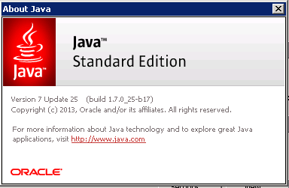

## Oracle Weblogic Server Configuration (Install and Upgrade)

Please note that this section is applicable when performing an install or upgrade for 4.7.0.0 (as opposed to previous releases). Please note that further configuration is required when installing the map server software and configuring the MapViewer product.

Please ensure that the Weblogic Application Server is installed and Fusion Middleware Forms and Reports are installed and configured before proceeding.

Bentley-exor release 4.7.0.0 makes use of WebUtil functionality within the Oracle Weblogic Server Technology stack for Maintenance Manager (Inspection Loader), Document Manager (uploading documents and Document Bundle Loader) and the Process Framework. This requires additional configuration within the Weblogic Server Fusion Middleware Forms deployment.

The Jar files being provided in this release have been signed. The certificates are due to expire around 2015. Please be aware that unsigned Jar files can lead to a potential issue whereby the forms start-up process will hang. For more information on the workaround please see documents on the Oracle support web site by referencing the documents below:

* Windows Java Client Hangs On Accepting Not Verified Signature Of jar Files When SeparateFrame=True (Doc ID 1173365.1)
* Form Hangs When Acknowledging Security Warning - The application's digital signature cannot be verified (Doc ID 1328039.1)

Alternatively see:

* <http://www.snapdba.com/2013/04/forms-11g-java-client-hangs-at-security-warning-with-the-applications-digital-signature-cannot-be-verified/>

### Deployment of forms and webutil Jar files

This section describes the deployment of the Jar files on the WebLogic server. Deployment of MapViewer Jar files is covered in the chapter specifically relating to the MapViewer installation.

NOTE in order to edit this file the Forms Service must be down, stop the Form Service using Fusion Middleware control.

Locate the following files in <exor_base>\weblogic\ directory –

* frmall.jar
* frmwebutil.jar
* jacob.jar (version 1.14.3)
* jacob-1.14.3-x64.dll
* jacob-1.14.3-x86.dll;

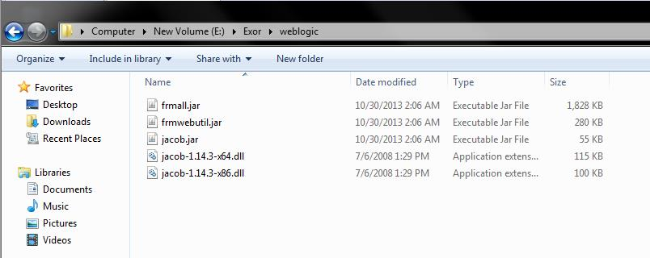

Copy

jacob-1.14.3-x64.dll into <ORACLE_HOME>\forms\webutil\win64\ and

jacob-1.14.3-x86.dll into <ORACLE_HOME>\forms\webutil\win32\

directories of the WebLogic Server –

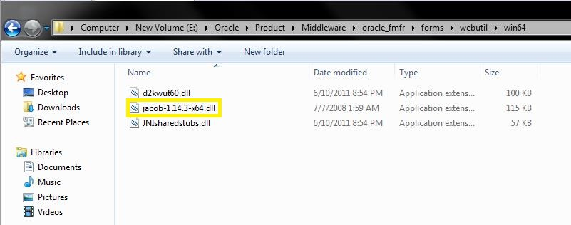

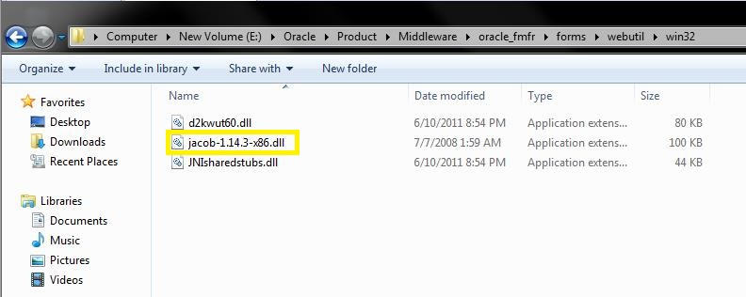

Copy the jacob.jar and Copy and Replace the frmall.jar and frmwebutil.jar into the <ORACLE_HOME>\forms\java\ directory of the WebLogic Server –

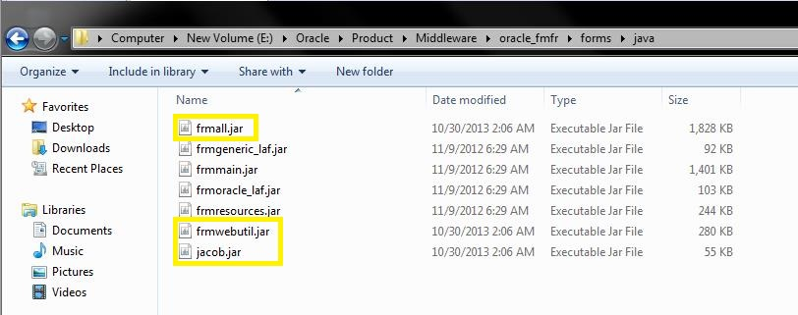

### Edit webutiljpi.htm

It is not possible to edit the webutiljpi.htm file via enterprise manager; navigate to <ORACLE_INSTANCE>\config\FormsComponent\forms\server and open the webutiljpi.htm file using a suitable text editor.

The new PARAMETER_NAME and EMBEDDED SRC to allow a specific java version to be used should be added to the file in two sections, first the ‘Registration applet definition (start)’ section, then the ‘Forms applet definition (start)’ section – NOTE: in this section you will have to scroll down to the EMBED SRC section to add java_version. The screen shots below indicate this.

NOTE in order to edit this file the Forms Service must be down, stop the Form Service using Fusion Middleware control.

Add the new PARAMETER_NAME and EMBEDDED SRC as per below and save the file.

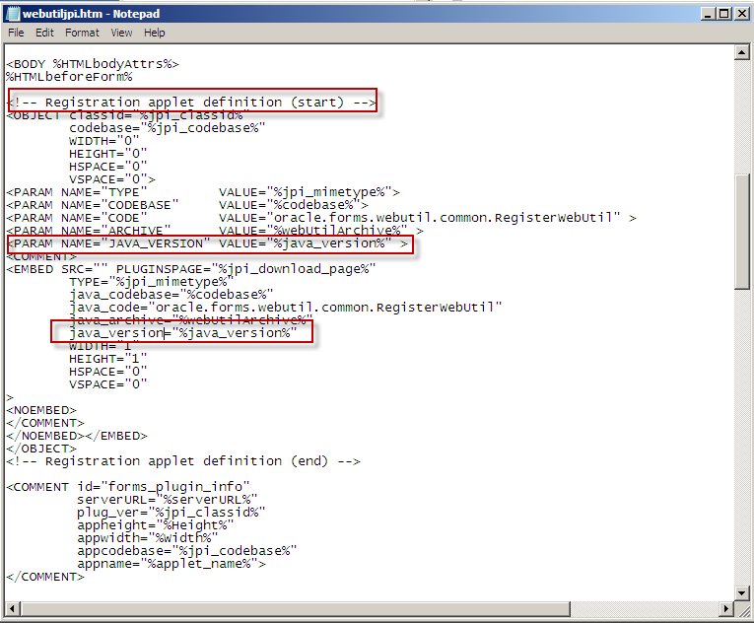

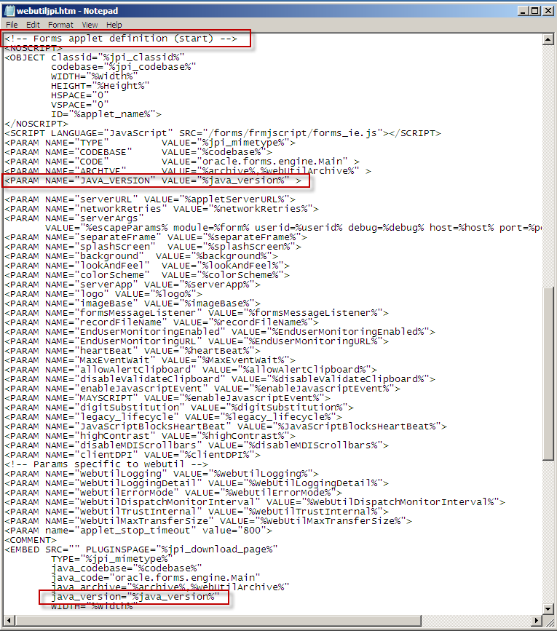

This additional new parameter allows the Application to force the use of a specific version of JRE specified in the formsweb.cfg file. Once the changes are completed the Forms services may be started.

### Configure the Forms Service to use WebUtil

Oracle Weblogic Server 10.3.6 - it is advisable to edit the configuration files using Fusion Middleware Control.

Add the additional parameters to the default section of formsweb.cfg using Fusion Middleware control:

|  |  |
| --- | --- |
| Parameter | Value |
| term | <ORACLE_HOME>\config\FormsComponent\forms\fmrpcweb.res |
| baseHTML | <ORACLE_HOME>\config\FormsComponent\forms\server\webutilbase.htm |
| baseHTMLjpi | <ORACLE_HOME>\config\FormsComponent\forms\server\webutiljpi.htm |
| highContrast | TRUE |
| height | 100% |
| form | hig1807.fmx |
| width | 100% |
| archive | frmall.jar,exor_jpg.jar,exorMapviewer4700_10_3_6.jar,mvclient_10_3_6.jar,ojdbc6_10_3_6.jar,UploadClient.jar,  UploadServer.jar |
| separateFrame | true |
| lookandfeel | oracle |
| WorkingDirectory | <exor_base>\bin |
| WebUtilArchive | jacob.jar,frmwebutil.jar |
| WebUtilLogging | on |
| WebutilLoggingDetails | normal |
| WebUtilErrorMode | console |
| WebUtilDispatchMonitorInterval | 5 |
| WebUtilTrustInternal | true |
| WebUtilMaxTransferSize | 16384 |

Note: Maintain the sequence of jar files for archive and WebUtilArchive parameters as mentioned in the above table.

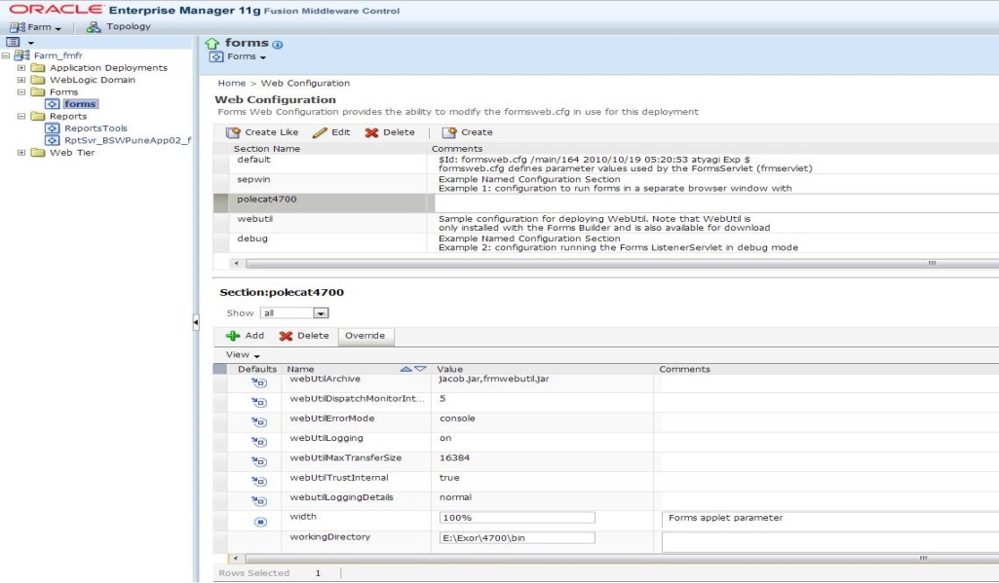

Ensure that frmwebutil.jar exists in the CLASSPATH variable and if it does not, add it now.

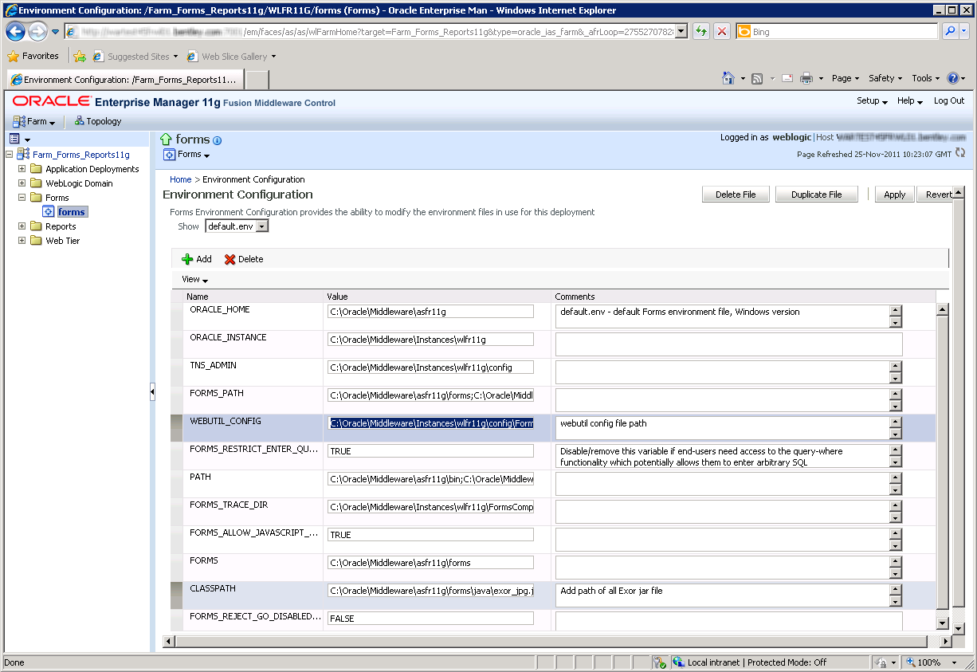

### Configure the WebUtil

Edit the file, using a suitable text editor, located in the folder <ORACLE_INSTANCE>\config\FormsComponent\forms\server called webutil.cfg. There are numerous options that can be configured in webutil.cfg relating to Logging, OS specifics, Upload/Download, and work areas. Initially we only configure the File Transfer which requires the following change to webutil.cfg

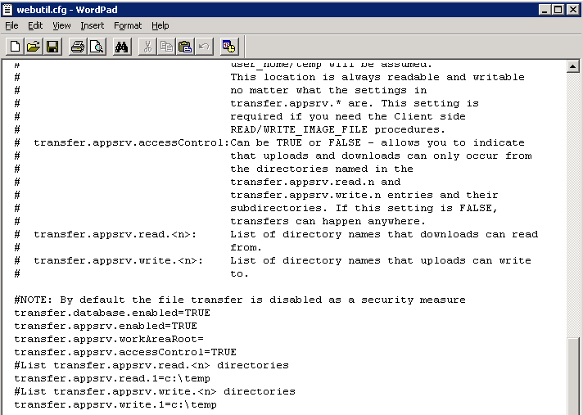

In the example above we have set the database and appsrv to be ‘TRUE’ with the default settings for transfer.appsrv.read and transfer.appsrv.write being at the default of c:\temp. We may need to add additional folders here to allow the upload on Maintenance Manager files etc to the specific Exor Directories.

### Forms startup

Please note that after deploying the pre-signed Jar files, starting the forms application may show a screen as shown below. Accept the warning by using the tick-box as shown. This is further described after the completing the installation of MapViewer (see Mapserver install)

# Network Manager

## Installation of the Network Manager Software files

To install the software components for Network Manager first check that the NM3 folder is present and correctly unzipped from the release zip file.

Important:

All exor applications that you install must go into the same destination – what is often referred to as <exor_base>.

## Highways Owner Account (Install Only)

This section provides details of steps involved in creating as owner for all exor database objects.

It is important that you should only perform these steps if you do not already have a "Highways Owner" account. If you are upgrading Network Manager then skip to the section which relates specifically to the upgrade.

### Before you start:

Before proceeding please ensure that the pre-requisites mentioned in Section 2.3 of this document are met.

Also, please be aware of the following;

Where instructed to change to a directory before running a script, it is assumed that you are running SQL*PLUS from a DOS Command prompt.

If you are running SQL*PLUS in windows you should set the 'start in' directory of the SQL*PLUS shortcut to simulate the change of directory.

If you do not run SQL*PLUS from the directory stated in each step of the guide, the installation will fail.

Also, whilst following the instructions in this section you will be required to know the location of <exor_base>. You may recall that whilst undertaking the tasks in Section 3.1 you will have implemented software into the location referred to as <exor_base>, for example, C:\EXOR.

### Product Run-time Environment

In the case of installation or upgrade of many of the products, the system depends on a properly configured middle-tier with a suitably configured folder containing all the run-time modules. These will be held in the product release installation folder such as <exor_base>\<prod>\11g_bin where <prod> refers to the product code such as nm3. These files will need to be copied into the fusion-middleware folder dedicated for this purpose.

Some products may also include executable files that run outside of the Oracle middle-tier and reference a database server only. These files such as listeners and C executable such as loaders will be contained inside the <exor_base>\<prod>\admin\C\11g_exe folder. It is important that these files are installed and executed in a suitable environment but this need not be the same as the product execution folder for forms and reports.

If in any doubt please raise a ticket at http://selectservices.bentley.com.

### Creation of a Highways Owner

The following paragraphs should be used to create a new schema for the implementation of Network Manager and any other subsequent exor application.

#### Tablespace Requirements

The following tablespaces (or equivalents) should be made available on your server:

HIGHWAYS Default Table Space. Can be a different name if required.

TEMP Default temporary Tablespace for users. Can be a different name.

#### Data Dictionary Privileges

Change directory to <exor_base>\nm3\install

Login to SQL*PLUS as the SYS user on the client PC and run the following command:

start hig_sys_grants.sql

#### The higowner script

Change directory to <exor_base>\nm3\install

Login to SQL*PLUS as the SYSTEM user on the client PC and run the following command:

start higowner.sql

This script will prompt you for the following information:

|  |  |
| --- | --- |
| Prompt | Meaning |
| Highways Owner Name | This should be the name to be given to your highways owner |
| Owner’s Password | Password for highways owner |
| Default Tablespace | Default Tablespace for highways owner |
| Temporary Tablespace | Temporary Tablespace for highways owner |
| System Start Date | This is the earliest date at which data is valid in your database |
| Admin Type Code | Code for the default admin unit type |
| Admin Type Description | Description for the default admin unit type |
| Admin Unit Code | Code for the default Admin Unit |
| Admin Unit Description | Description for the default Admin Unit |

You will now have a new Oracle user set up with all relevant privileges to run the highways application. Also the system start date for your database will have been set and Top level Admin Unit created for your default Admin Unit Type.

## Network Manager Install/Upgrade

This section provides details of steps involved in installing/upgrading the server components for Network Manager to 4.7.0.0.

Important:

This product will require upgrading before any other 4.7.0.0 product upgrades.

### Before you start

Before proceeding please ensure that the pre-requisites mentioned in Section 2.3 of this document are met.

Also, please be aware of the following;

Where instructed to change to a directory before running a script, it is assumed that you are running SQL*PLUS from a DOS Command prompt.

If you are running SQL*PLUS in windows you should set the 'start in' directory of the SQL*PLUS shortcut to simulate the change of directory.

If you do not run SQL*PLUS from the directory stated in each step of the guide, the installation will fail.

Also, whilst following the instructions in this section you will be required to know the location of <exor_base>. You may recall that whilst undertaking the tasks in Section 3.1 you will have implemented software into the location referred to as <exor_base>, for example, C:\EXOR.

### Typical problems that you may encounter

It is possible that, when you are running some of the upgrade scripts, errors may be reported saying that objects already exist in the database or that columns already exist on tables. These errors can generally be ignored. If you are in any doubt, please contact the Exor support desk for guidance.

The upgrade procedures will also attempt to install database roles in the highways owner account that are necessary for the system to operate correctly. You may find that errors are produced when running the upgrade scripts to the effect that the role names being created are already used by existing roles or users. These errors can be ignored as they simply mean that the roles being created already exist.

Also during install/upgrade Warning messages may appear saying that compilation errors have occurred. These warnings can be ignored, since invalid objects will be recompiled later on in the install/upgrade. However it will be of concern if compilation errors still occur following the re-compilation.

### Install of Network manager

#### Core User and Objects

The following should be used to create a new schema for the implementation of Context Setting. This step is only required for a new install of Network Manager (i.e. not required if upgrading from a previous version of Network Manager).

Change directory to <exor_base>\nm3\install

Login to SQL*PLUS as the SYSTEM user on the client PC and

run the following command:

start exor_core_user_creation.sql

Login to SQL*PLUS as the EXOR_CORE user (Password EXOR_CORE) on the client PC and

run the following command:

start exor_core_objects.sql

Then continue with the Install of Network Manager.

#### Install of Network Manager

To create the base data and objects for Network Manager modules;

Change directory to <exor_base>\nm3\install

Login to SQL*PLUS as the highways owner on the client PC and run the following command:

  start nm_inst.sql

You will be prompted to enter the path of the location of your highways software. This should be name of the directory, including disk identifier and a trailing slash character, referred to as <exor_base>.

For example, if you installed your highways software in a directory called EXOR on your C drive, you would enter the following when prompted.

C:\EXOR\

When you have supplied this value, you will be prompted to confirm that it is correct and asked whether you wish to continue.

If the value specified is not correct or does not end with a slash character, you will be given an error message and the installation script will abort. You will then need to login to SQL*PLUS again and rerun the script.

When the script has completed, all the Network Manager objects and data will have been installed.

#### Checking Log File(s)

The following log files are produced in the working directory. At the end of the installation, the files can be viewed to check for any errors that could have occurred during installation.

nm3_install_1_<date&time>.LOG

nm3_install_2_<date&time>.LOG

Note:

it is perfectly normal for the NM3SDE package to not compile if an SDE schema does not exist or if the highways owner has no privilege to read SDE objects.

Please raise and attach the logs to a ticket with <http://selectservices.bentley.com> to allow Bentley (formerly exor) support staff to verify the install has been successful.

### Post Install Tasks

Creation of Additional Database Objects

Once an install has been completed the following batch files must be run;

import_nm_upload_files.bat

ldjava_11g.bat (for customers with an Oracle 11gR2 RDBMS)

These may be found in the <exor_base>\nm3\install\ directory and should be run from the command prompt.

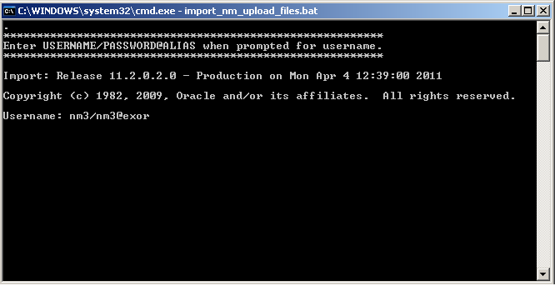

You will be prompted for the Username of the Highways Owner. Enter the Username/Password@alias then press Enter, e.g. nm3/nm3@exor

#### Synonyms

Highways product option HIGPUBSYN is used to dictate whether or not Public database synonyms are used.

On first time installation of Network Manager synonyms are NOT created. So to create synonyms following installation, use the Highways application to set product option HIGPUBSYN and then within SQL*Plus run the following command;

EXECUTE nm3ddl.refresh_all_synonyms;

Note:

if you opt to not use Public Synonyms, then Private synonyms are created for all subordinate users when the above command is executed.

#### Configuring NM3WEB

This section provides details of steps involved in configuring the Gateway Database Access Descriptor to allow access to the Web modules used within Highways by Exor.

These include modules such as the

CSV Loaders - HIGWEB2030

Engineering Dynamic Segmentation - NMWEB0020.

It refers to the base directory for files accessed through the OHS Weblogic server. By default this is <ORACLE_INSTANCE>\config\OHS\ohs1\mod_plsql\dads.conf.

A Database Access Descriptor (DAD) must be created to handle the connection to the database by the web server.

From the Oracle HTTP Server Advanced Server Configuration using Fusion Middleware control page

Select dad.conf from files to be edited:

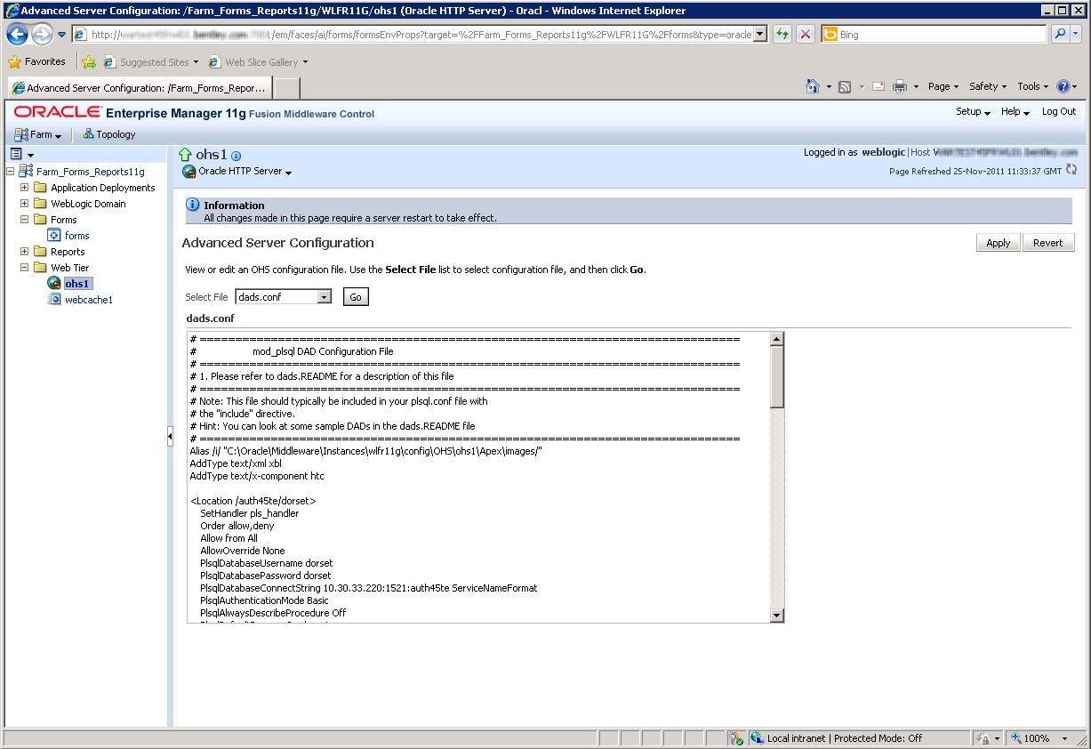

Database Access Descriptor Name (<Location /NM3WEB>) should be NM3WEB

Fill in user, password and database as required.

You can leave the password and/or username blank to force the user to enter them (recommended).

PlsqlDatabaseUsername should be blank.

PlsqlDatabasePassword should be blank.

Authentication method (PlsqlAuthenticationMode) should be Basic.

Default Home page (PlsqlDefaultPage) should be nm3web.main_menu.

Document Table name (PlsqlDocumentTablename) should be NM_UPLOAD_FILES.

Document Access Path (PlsqlDocumentPath) should be the value set for Product Option WEBDOCPATH. The standard metadata value is DOCS

Document Access Procedure (PlsqlDocumentProcedure) should be nm3web.process_download

Click OK button at top of page.

Note:

In order to access the Web Modules the User must be granted the appropriate Roles for the Module. Refer to the General System Admin Guide for more information on User Roles

For example:

<Location /NM3WEB>

SetHandler pls_handler

Order allow,deny

Allow from All

AllowOverride None

PlsqlDatabaseUsername <recommended to be blank>

PlsqlDatabasePassword < recommended to be blank >

PlsqlDatabaseConnectString <hostname>:<port>:<service_name> ServiceNameFormat

PlsqlAuthenticationMode Basic

PlsqlAlwaysDescribeProcedure Off

PlsqlDefaultPage nm3web.main_menu

PlsqlDocumentProcedure nm3web.process_download

PlsqlErrorStyle <as required>

PlsqlDocumentPath DOCS

PlsqlDocumentTablename NM_UPLOAD_FILES

</Location>

#### Forms 11g Specific Configuration

There are certain product options which must be set according to the Oracle forms version that is being used to run the exor application.

REPURL

The value of this product option should be set to the URL that identifies the 11g Fusion Middleware Reports Server.

e.g.

**Error! Hyperlink reference not valid.**>

### Upgrade of Network Manager

#### Upgrade of Network Manager

This section describes the steps necessary to upgrade Network Manager to 4.7.0.0

To upgrade the base data and objects for the Network Manager modules;

* Change directory to <exor_base>\nm3\install
* Login to SQL*PLUS as the highways owner on the client PC
* Run one of the following commands commands depending on which version you are upgrading from. For an upgrade from 4.6

start nm4600_nm4700.sql

For an upgrade from 4.5:

start nm4500_nm4700.sql

* You will be prompted to enter the path of the location of your highways software. This should be name of the directory, including disk identifier and a trailing slash character, referred to as <exor_base>.

For example, if you installed your highways software in a directory called EXOR on your C drive, you would enter the following when prompted.

C:\EXOR\

* When you have supplied this value, you will be prompted to confirm that it is correct and asked whether you wish to continue.
* If the value specified is not correct or does not end with a slash character, you will be given an error message and the installation script will abort. You will then need to login to SQL*PLUS again and rerun the script.
* When the script has completed, all the Network Manager objects and data will have been upgraded.

#### Checking Log File(s)

The following log files are produced in the working directory. At the end of the upgrade, they can be viewed to check for any errors that could have occurred during the upgrade process.

Nm<xx>00_nm4700_1_<date&time>.LOG

Nm<xx>00_nm4700_2_<date&time>.LOG

where <xx> refers to the original release number (i.e. 45 or 46)

Please raise and attach the logs to a ticket with <http://selectservices.bentley.com> to allow Bentley (formerly exor) support staff to verify the upgrade has been successful.

Due to interdependencies between some Exor products, please ignore all compilation errors until all of your products have been upgraded.

### Mandatory Configuration (Post Install and Upgrade)

#### exor_version.txt

Before accessing Network Manager you must check the file exor_version.txt.

This file is referenced in Windows Registry setting ‘EXOR_VERSION’ and by default can be located in the <exor_base>\11g_bin directory.

Ensure that the entry for Network Manager is set accordingly;

NET=4.7.0.0

HIG=4.7.0.0

AST=4.7.0.0

DOC=4.7.0.0

WMP=4.7.0.0

### EXOR_JPG.JAR (Post Install and Upgrade)

Copy the new EXOR_JPG.JAR from the <exor_base>/icons/java folder to the <forms_home>/java folder on the application server.

Users may need to clear their JRE caches to see the changes.

### Process Framework (Post Install and Upgrade)

The Process Framework can be started (or stopped) via the Process Framework Administration form (hig2550). After successfully completing installs or upgrades to 4.5.0.0 for all products required navigate to this form and use the Start Up button to start up the Process Framework.

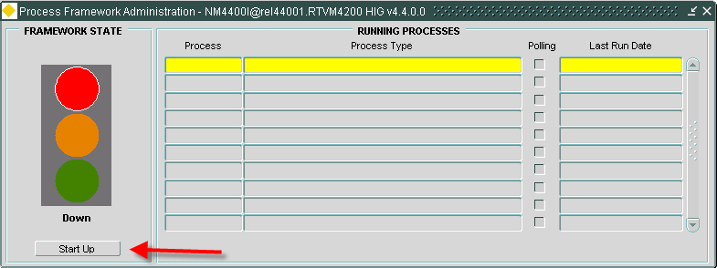

### Jobs (Post Install and Upgrade)

After completing a successful install/upgrade of all products required to 4.7.0.0 please execute the following script to start/restart Core jobs:

* Change directory to <exor_base>\nm3\install
* Login to SQL*PLUS as the highways owner on the client PC
* Run the following command

start nm3jobs.sql

### Spatial Configuration (Post Install and Upgrade)

Specific information regarding the registration of spatial layers can be found in the “Locator and Web Mapping” document.

### Doc Bundle Loader (Post Install and Upgrade)

#### Oracle External Scheduler Jobs

* For databases that exist on a Windows Operating System – The OracleJobScheduler<instance> service MUST be running on the database server.
* For databases that exist on a Solaris/Linux Operating System – Relevant permissions to execute <db_home>/bin/extjob must be set in accordance with Oracle Documentation.
* External Jobs are not supported on any other platform.

### Optional Security Policies

Fixes were available on the 4.6.0.0 platform of Exor Highways to enable extra security policies to be configured. These are available as a package (NM3NWAUSEC) and a set of policies. Policies will be dropped during the install and upgrade and although the packages to support the policies will be present for all, those who wish to invoke the optional security policies will need to re-install them. To do this, execute the add_nm3nwausec_policies.sql script as the highways owner. The file is found in <exor_base>\nm3\admin\ctx

### Additional Configuration (Post Install and Upgrade)

Consult the documentation that accompanies this release for details of any additional configuration that may be required following an install/upgrade.

For example, to obtain details of product options, and for details of new product features/amendments.

Important:

It is highly recommended that you do this before attempting to use the application.

### Mapserver Component Install (Post Install and Upgrade)

At version 4.7.0.0 of the Exor Application set, locator mapping software using Oracle Weblogic Application Server Mapviewer version 11.1.1.7.1 should be installed and configured.

Locate the <exor_base>\msv\exorMapviewer4700 where you will find:

* exorMapviewer4600_10_3_6.jar

and in <exor_base>\msv\mvclient where you will find mvclient_10_3_5.jar. Copy these files to <oracle_home>\forms\java.

The formsweb.cfg archive parameter should be appended with the file name

* exorMapviewer4500_10_3_6.jar
* mvclient_10_3_6.jar.

Copy these files to <ORACLE_HOME>\forms\java

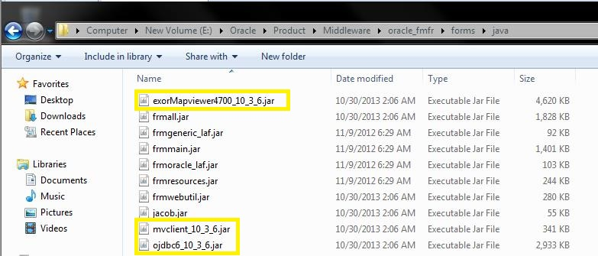

The formsweb.cfg archive parameter should be appended with the file names exorMapviewer4700_10_3_6.jar, ojdbc6_10_3_6.jar and mvclient_10_3_6.jar.

For example (formsweb.conf):

archive= frmall.jar,exor_jpg.jar,exorMapviewer4700_10_3_6.jar,mvclient_10_3_6.jar,ojdbc6_10_3_6.jar,UploadClient.jar,

UploadServer.jar

On each client machine the Jar Cache will need to be cleared. This can be done by the following methods.

Oracle JRE users

Open Java Control Panel as below -

Start -> Control Panel -> Java.

Navigate to the "General" tab and click "Settings" button. In the Disk Space section click "Delete Files" button

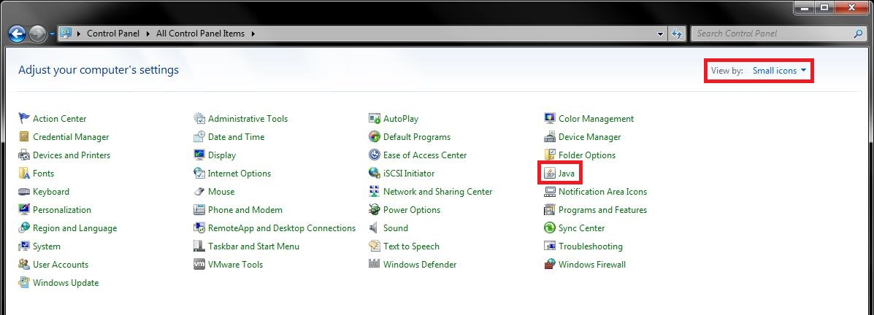

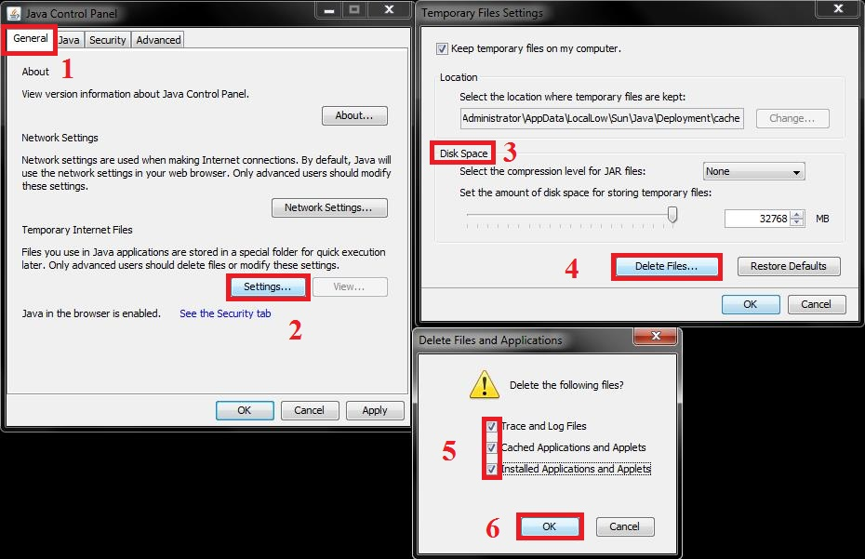

When you launch the Exor Application for the first time a java security warning will appear. Select the checkbox in front of ‘Do not show this again for apps from the publisher and location above’ as shown in the following screenshot and then click Run –

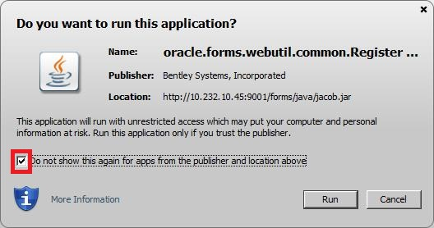

Again open the Java Control Panel as described above. In the Java Control Panel go to –

Security -> Manage Certificates…

Now you will see the Bentley Systems, Incorporated Certificate installed and listed under Trusted Certificate.

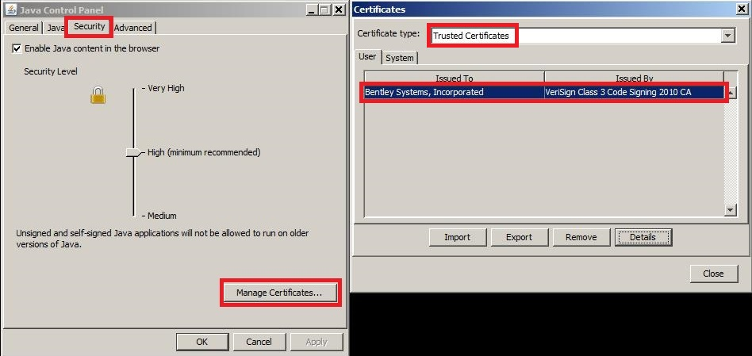

Close the Java Control Panel.

After this, you should not see any warnings in future, unless the certificate gets removed.

You should now load the Exor Application in the usual way. On the first load, it will take longer than usual whilst the JAR files are cached again.

MV_SECURITY Option

Please ensure that the MV_SECURITY option in the Mapviewer config file is set to FALSE. This has to be set to FALSE so that the Java code can create a data source on the fly when the preferred data source is not set.

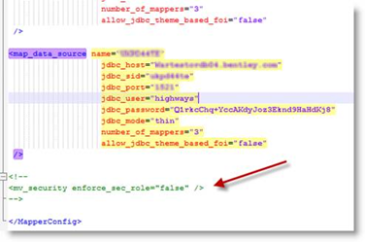

# Street Gazetteer Manager

## Implementation of the Street Gazetteer Manager Software files

To install the software components for Street Gazetteer Manager first check that the NSG folder is present and correctly unzipped from the release zip file.

Important:

All exor applications that you install must go into the same destination – what is often referred to as <exor_base>.

## Street Gazetteer Manager Server Upgrade

This chapter provides details of steps involved in upgrading the server components for Street Gazetteer Manager.

Important:

This product will require upgrading after Network Manager and before Maintenance Manager, Enquiry Manager and TMA Manager.

### Before you Start

Before proceeding please ensure that the pre-requisites mentioned in Section 2.3 of this document are met.

Also, please be aware of the following;

Where instructed to change to a directory before running a script, it is assumed that you are running SQL*PLUS from a DOS Command prompt.

If you are running SQL*PLUS in windows you should set the 'start in' directory of the SQL*PLUS shortcut to simulate the change of directory.

If you do not run SQL*PLUS from the directory stated in each step of the guide, the installation will fail.

Also, whilst following the instructions in this section you will be required to know the location of <exor_base>. You may recall that whilst undertaking the tasks in the previous subsection you will have implemented software into the location referred to as <exor_base>, for example, C:\EXOR.

### Typical problems that you may encounter

It is possible that, when you are running some of the upgrade scripts, errors may be reported saying that objects already exist in the database or that columns already exist on tables. These errors can generally be ignored. If you are in any doubt, please contact the Exor support desk for guidance.

The upgrade procedures will also attempt to install database roles in the highways owner account that are necessary for the system to operate correctly. You may find that errors are produced when running the upgrade scripts to the effect that the role names being created are already used by existing roles or users. These errors can be ignored as they simply mean that the roles being created already exist.

Also during install/upgrade Warning messages may appear saying that compilation errors have occurred. These warnings can be ignored, since invalid objects will be recompiled later on in the install/upgrade. However it will be of concern if compilation errors still occur following the re-compilation.

### Install of Street Gazetteer manager

To create the base data and objects for Street Gazetteer Manager modules;

Change directory to <exor_base>\nsg\install

Login to SQL*PLUS as the highways owner on the client PC and run the following command:

  start nsg_inst.sql

You will be prompted to enter the path of the location of your highways software. This should be name of the directory, including disk identifier and a trailing slash character, referred to as <exor_base>.

For example, if you installed your highways software in a directory called EXOR on your C drive, you would enter the following when prompted.

C:\EXOR\

When you have supplied this value, you will be prompted to confirm that it is correct and asked whether you wish to continue.

If the value specified is not correct or does not end with a slash character, you will be given an error message and the installation script will abort. You will then need to login to SQL*PLUS again and rerun the script.

When the script has completed, all the Street Gazetteer Manager objects and data will have been installed.

### Checking Log File(s)

The following log files are produced in the working directory. At the end of the installation, the files can be viewed to check for any errors that could have occurred during installation.

nsg_install_1_<date&time>.LOG

nsg_install_2_<date&time>.LOG

Please raise and attach the logs to a ticket with <http://selectservices.bentley.com> to allow Bentley (formerly exor) support staff to verify the install has been successful.

### Upgrade of Street Gazetteer Manager

This section describes the steps necessary to upgrade Street Gazetteer Manager to 4.7.0.0

To upgrade the base data and objects for the Street Gazetteer Manager modules;

Change directory to <exor_base>\nsg\install

Login to SQL*PLUS as the highways owner on the client PC

Run the following command

start nsg4500_nsg4600.sql

You will be prompted to enter the path of the location of your highways software. This should be name of the directory, including disk identifier and a trailing slash character, referred to as <exor_base>.

For example, if you installed your highways software in a directory called EXOR on your C drive, you would enter the following when prompted.

C:\EXOR\

When you have supplied this value, you will be prompted to confirm that it is correct and asked whether you wish to continue.

If the value specified is not correct or does not end with a slash character, you will be given an error message and the installation script will abort. You will then need to login to SQL*PLUS again and rerun the script.

When the script has completed, all the Street Gazetteer Manager objects and data will have been upgraded.

### Checking Log File(s)

The following log files are produced in the working directory. At the end of the upgrade, they can be viewed to check for any errors that could have occurred during the upgrade process.

nsg4500_nsg4600_1_<date&time>.LOG

nsg4500_nsg4600_2_<date&time>.LOG

Please raise and attach the logs to a ticket with <http://selectservices.bentley.com> to allow Bentley (formerly exor) support staff to verify the upgrade has been successful.

Due to interdependencies between some Exor products, please ignore all compilation errors until all of your products have been upgraded.

### Mandatory Configuration (Post Install and Upgrade)

exor_version.txt

Before accessing Street Gazetteer Manager you must check the file exor_version.txt.

This file is referenced in Windows Registry setting ‘EXOR_VERSION’ and by default can be located in the <exor_base>\11g_bin directory.

Ensure that the entry for Street Gazetteer Manager is set accordingly;

NSG=4.7.0.0

### Product Licencing (Post Install only)

Following first time installation you must licence the product for use.

To do this start highways by exor and invoke module HIG1890 from the Fastpath menu.

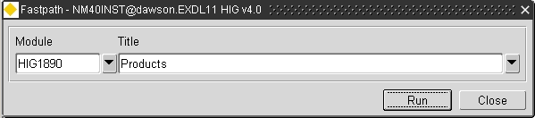

For further details please refer to the “Network Manager General System Admin Guide”

### Setting Directory Paths (Post Install only)

This step is only necessary following a first time Installation of Street Gazetteer Manager. The Setting of Directory Paths will have been implemented previously for an Upgrade.

Street Gazetteer Manager uses the Oracle directories mechanism to denote the locations of files that are read/written.

The following Oracle directories are utilised by Street Gazetteer Manager, and they must have their “File System Paths” set using module HIG1895.

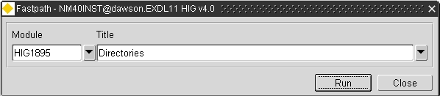

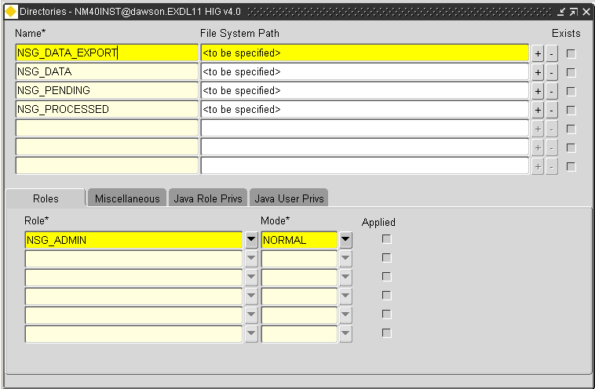

For more information regarding managing directories, please consult the “Network Manager General System Admin Guide”

### XSD Files (Post Install only)

This step is only necessary following a first time Installation of Street Gazetteer Manager. The XSD files will have been registered previously for an Upgrade.

Copy the .xsd files from <exor_base>\nsg\admin\xsd into a directory on the database server.

Log into the Highways By Exor application and open the ‘Directories’ module

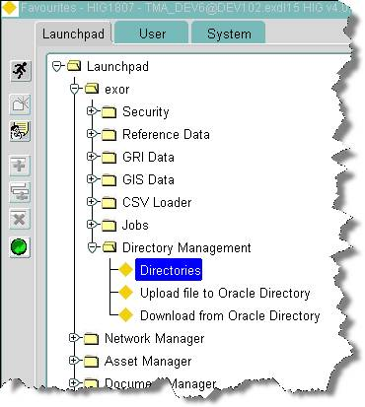

Ensure that the directory with the name ‘NSG_XSD_DIRECTORY’ has a path set that points to the location that you have just copied .xsd files into e.g.

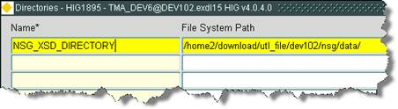

The XSD files must then be registered with Oracle XMLDB by running the script  <exor_base>\nsg\admin\xsd\register_eton_schemas.sql

### Creation of Loader Database Job (Post Install only)

Following first time installation, should it be necessary to load Gazetteer files a database job needs to be created.  To do this open the Highways application and run the ‘Monitor NSG Loader’ module (NSG0040).

Press the ‘Options’ button.

Press the ‘Recreate Job’ button.

### Rebuild the NSG Views (post Upgrade only)

Login to SQL*PLUS as the highways owner on the client PC

Run the following command:

BEGIN

  NSG_SDO_UTIL.REBUILD_NSG_VIEWS;

END;

/

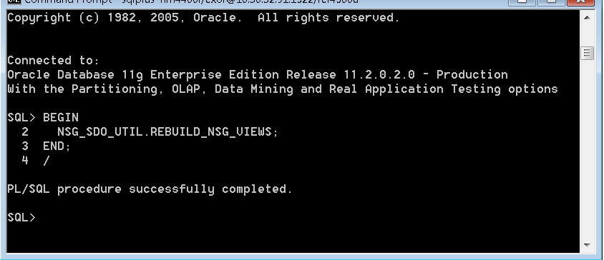

# Maintenance Manager

## Implementation of the Maintenance Manager Software files

To install the software components for Maintenance Manager first check that the MAI folder is present and correctly unzipped from the release zip file.

Important:

All exor applications that you install must go into the same destination – what is often referred to as <exor_base>.

## Maintenance Manager Server Install/Upgrade

This chapter provides details of steps involved in installing/upgrading the server components for Maintenance Manager.

### Before you Start

Before proceeding please ensure that the pre-requisites mentioned in Section 2.3 of this document are met.

Also, please be aware of the following;

Where an upgrade is to be performed please ensure that any data loading being done through the Maintenance Manager loader modules has been completed, any data held in the Maintenance Manager load tables may be removed during this upgrade.

Where instructed to change to a directory before running a script, it is assumed that you are running SQL*PLUS from a DOS Command prompt.

If you are running SQL*PLUS in windows you should set the 'start in' directory of the SQL*PLUS shortcut to simulate the change of directory.

If you do not run SQL*PLUS from the directory stated in each step of the guide, the installation will fail.

Also, whilst following the instructions in this section you will be required to know the location of <exor_base>. You may recall that whilst undertaking the tasks in the previous subsection you will have implemented software into the location referred to as <exor_base>, for example, C:\EXOR.

### Typical problems that you may encounter

It is possible that, when you are running some of the upgrade scripts, errors may be reported saying that objects already exist in the database or that columns already exist on tables. These errors can generally be ignored. If you are in any doubt, please contact the Exor support desk for guidance.

The upgrade procedures will also attempt to install database roles in the highways owner account that are necessary for the system to operate correctly. You may find that errors are produced when running the upgrade scripts to the effect that the role names being created are already used by existing roles or users. These errors can be ignored as they simply mean that the roles being created already exist.

Also during install/upgrade Warning messages may appear saying that compilation errors have occurred. These warnings can be ignored, since invalid objects will be recompiled prompt later on in the install/upgrade. However it will be of concern if compilation errors still occur following the re-compilation.

### Install of Maintenance Manager

To create the base data and objects for Maintenance Manager modules;

Change directory to <exor_base>\mai\install

Login to SQL*PLUS as the highways owner on the client PC and run the following command:

  start mai_inst.sql

You will be prompted to enter the path of the location of your highways software. This should be name of the directory, including disk identifier and a trailing slash character, referred to as <exor_base>.

For example, if you installed your highways software in a directory called EXOR on your C drive, you would enter the following when prompted.

C:\EXOR\

When you have supplied this value, you will be prompted to confirm that it is correct and asked whether you wish to continue.

If the value specified is not correct or does not end with a slash character, you will be given an error message and the installation script will abort. You will then need to login to SQL*PLUS again and rerun the script.

When the script has completed, all the Maintenance Manager objects and data will have been installed.

### Checking Log File(s)

The following log files are produced in the working directory. At the end of the installation, the files can be viewed to check for any errors that could have occurred during installation.

mai_install_1_<date&time>.LOG

mai_install_2_<date&time>.LOG

Please raise and attach the logs to a ticket with <http://selectservices.bentley.com> to allow Bentley (formerly exor) support staff to verify the install has been successful.

### Upgrade of Maintenance Manager

This section describes the steps necessary to upgrade Maintenance Manager to 4.7.0.0

To upgrade the base data and objects for the Maintenance Manager modules;

* Change directory to <exor_base>\mai\install
* Login to SQL*PLUS as the highways owner on the client PC
* Run one of the following commands commands depending on which version you are upgrading from.

For an upgrade from 4.5: start mai4500_mai4700.sql

For an upgrade from 4.5.2.0: start mai4520_mai4700.sql

For an upgrade from 4.6: start mai4600_mai4700.sql

For an upgrade from 4.6.1.0: start mai4610_mai4700.sql

* You will be prompted to enter the path of the location of your highways software. This should be name of the directory, including disk identifier and a trailing slash character, referred to as <exor_base>.

For example, if you installed your highways software in a directory called EXOR on your C drive, you would enter the following when prompted.

C:\EXOR\

* When you have supplied this value, you will be prompted to confirm that it is correct and asked whether you wish to continue.
* If the value specified is not correct or does not end with a slash character, you will be given an error message and the installation script will abort. You will then need to login to SQL*PLUS again and rerun the script.
* When the script has completed, all the Maintenance Manager objects and data will have been upgraded.

### Checking Log File(s)

The following log files are produced in the working directory. At the end of the upgrade, they can be viewed to check for any errors that could have occurred during the upgrade process.

mai<xx>_mai4700_1_<date&time>.LOG

mai<xx>_mai4700_2_<date&time>.LOG

where <xx> refers to the original release number (i.e. 4500, 4520, 4600 or 4610)

Please raise and attach the logs to a ticket with <http://selectservices.bentley.com> to allow Bentley (formerly exor) support staff to verify the upgrade has been successful.

Due to interdependencies between some Exor products, please ignore all compilation errors until all of your products have been upgraded.

### Mandatory Configuration (Post Install and Upgrade)

#### exor_version.txt

Before accessing Maintenance Manager you must check the file exor_version.txt.

This file is referenced in Windows Registry setting ‘EXOR_VERSION’ and by default can be located in the <exor_base>\11g_bin directory.

Ensure that the entry for Maintenance Manager is set accordingly;

MAI=4.7.0.0

### Conflated Networks (Post Install only)

Customers using a Conflated Network must run an additional script to implement an appropriate view for Cyclic Maintenance.

NB This step is not required if the Maintenance Sections used by Maintenance Manager are Datum Elements.

To implement the view;

* Change directory to <exor_base>\mai\admin\views
* Login to SQL*PLUS as the highways owner on the client PC
* Run the following command

start inv_items_all_section.sql

* You will be prompted to enter the Group Type of the Maintenance Sections used by Maintenance Manager.
* When you have supplied this value press enter and the script will create the appropriate view.

### Additional Configuration (Post Install and Upgrade)

Consult the documentation that accompanies this release for details of any additional configuration that may be required following an install/upgrade.

For example, to obtain details of product options, and for details of new product features/amendments.

Important:

It is highly recommended that you do this before attempting to use the application.

### Product Licencing (Post Install only)

Following first time installation you must licence the product for use.

To do this start highways by exor and invoke module HIG1890 from the Fastpath menu.



For further details please refer to the “Network Manager General System Admin Guide”

### Spatial Configuration (Post Install and Upgrade)

Specific information regarding the registration of spatial layers can be found in the “Locator and Web Mapping” document.

# Enquiry Manager

## Implementation of the Enquiry Manager Software files

To install the software components for Enquiry Manager first check that the PEM folder is present and correctly unzipped from the release zip file.

Important:

All exor applications that you install must go into the same destination – what is often referred to as <exor_base>.

## Enquiry Manager Server Install/Upgrade

This chapter provides details of steps involved in installing/upgrading the server components for Enquiry Manager.

Important:

This product will require installing/upgrading after Network Manager and Maintenance Manager.

### Before you Start

Before proceeding please ensure that the pre-requisites mentioned in Section 2.3 of this document are met.

Also, please be aware of the following;

Where instructed to change to a directory before running a script, it is assumed that you are running SQL*PLUS from a DOS Command prompt.

If you are running SQL*PLUS in windows you should set the 'start in' directory of the SQL*PLUS shortcut to simulate the change of directory.

If you do not run SQL*PLUS from the directory stated in each step of the guide, the installation will fail.

Also, whilst following the instructions in this section you will be required to know the location of <exor_base>. You may recall that whilst undertaking the tasks in the previous subsection you will have implemented software into the location referred to as <exor_base>, for example, C:\EXOR.

### Typical problems that you may encounter

It is possible that, when you are running some of the upgrade scripts, errors may be reported saying that objects already exist in the database or that columns already exist on tables. These errors can generally be ignored. If you are in any doubt, please contact the Exor support desk for guidance.

The upgrade procedures will also attempt to install database roles in the highways owner account that are necessary for the system to operate correctly. You may find that errors are produced when running the upgrade scripts to the effect that the role names being created are already used by existing roles or users. These errors can be ignored as they simply mean that the roles being created already exist.

Also during install/upgrade Warning messages may appear saying that compilation errors have occurred. These warnings can be ignored, since invalid objects will be recompiled prompt later on in the install/upgrade. However it will be of concern if compilation errors still occur following the re-compilation.

### Install of Enquiry Manager

To create the base data and objects for Enquiry Manager modules;

Change directory to <exor_base>\pem\install

Login to SQL*PLUS as the highways owner on the client PC and run the following command:

  start pem_inst.sql

You will be prompted to enter the path of the location of your highways software. This should be name of the directory, including disk identifier and a trailing slash character, referred to as <exor_base>.

For example, if you installed your highways software in a directory called EXOR on your C drive, you would enter the following when prompted.

C:\EXOR\

When you have supplied this value, you will be prompted to confirm that it is correct and asked whether you wish to continue.

If the value specified is not correct or does not end with a slash character, you will be given an error message and the installation script will abort. You will then need to login to SQL*PLUS again and rerun the script.

When the script has completed, all the Enquiry Manager objects and data will have been installed.

### Checking Log File(s)

The following log files are produced in the working directory. At the end of the installation, the files can be viewed to check for any errors that could have occurred during installation.

pem_install_1_<date&time>.LOG

pem_install_2_<date&time>.LOG

Please raise and attach the logs to a ticket with <http://selectservices.bentley.com> to allow Bentley (formerly exor) support staff to verify the install has been successful.

### Upgrade of Enquiry Manager

This section describes the steps necessary to upgrade Enquiry Manager to 4.7.0.0

To upgrade the base data and objects for the Enquiry Manager modules;

* Change directory to <exor_base>\pem\install
* Login to SQL*PLUS as the highways owner on the client PC
* Run one of the following commands depending on which version you are upgrading from.

For an upgrade from 4.5: start pem4500_pem4700.sql

For an upgrade from 4.5.2.0: start pem4520_pem4700.sql

For an upgrade from 4.6: start pem4600_pem4700.sql

For an upgrade from 4.6.1.0: start pem4610_pem4700.sql

* You will be prompted to enter the path of the location of your highways software. This should be name of the directory, including disk identifier and a trailing slash character, referred to as <exor_base>.

For example, if you installed your highways software in a directory called EXOR on your C drive, you would enter the following when prompted.

C:\EXOR\

* When you have supplied this value, you will be prompted to confirm that it is correct and asked whether you wish to continue.
* If the value specified is not correct or does not end with a slash character, you will be given an error message and the installation script will abort. You will then need to login to SQL*PLUS again and rerun the script.
* When the script has completed, all the Enquiry Manager objects and data will have been upgraded.

### Checking Log File(s)

The following log files are produced in the working directory. At the end of the upgrade, they can be viewed to check for any errors that could have occurred during the upgrade process.

pem<xx>_pem4700_1_<date&time>.LOG

pem<xx>_pem4700_2_<date&time>.LOG

where <xx> refers to the original release number (i.e. 4500, 4520, 4600 or 4610)

Please raise and attach the logs to a ticket with <http://selectservices.bentley.com> to allow Bentley (formerly exor) support staff to verify the upgrade has been successful.

Due to interdependencies between some Exor products, please ignore all compilation errors until all of your products have been upgraded.

### Mandatory Configuration (Post Install and Upgrade)

#### exor_version.txt

Before accessing Enquiry Manager you must check the file exor_version.txt.

This file is referenced in Windows Registry setting ‘EXOR_VERSION’ and by default can be located in the <exor_base>\11g_bin directory.

Ensure that the entry for Enquiry Manager is set accordingly;

PEM=4.7.0.0

### Additional Configuration (Post Install and Upgrade)

Consult the documentation that accompanies this release for details of any additional configuration that may be required following an install/upgrade.

For example, to obtain details of product options, and for details of new product features/amendments.

Important:

It is highly recommended that you do this before attempting to use the application.

### Product Licencing (Post Install only)

Following first time installation you must licence the product for use.

To do this start highways by exor and invoke module HIG1890 from the Fastpath menu.



For further details please refer to the “Network Manager General System Admin Guide”

### Spatial Configuration (Post Install and Upgrade)

Specific information regarding the registration of spatial layers can be found in the “Locator and Web Mapping” document.

# TMA Manager

## Implementation of the TMA Manager Software files

To install the software components for TMA Manager first check that the TMA folder is present and correctly unzipped from the release zip file.

Important:

All exor applications that you install must go into the same destination – what is often referred to as <exor_base>.

## TMA Manager Server Install/Upgrade

This chapter provides details of steps involved in installing/upgrading the server components for TMA Manager.

Please note that from v4.5.10. the external api no longer requires a separate installation or upgrade, as the external api is now included within the TMA application.

Important:

This product will require installing/upgrading after Network Manager and Street Gazetteer Manager.

### Before you Start

Before proceeding please ensure that the pre-requisites mentioned in Section 2.3 of this document are met.

Also, please be aware of the following;

**Extremely Important (When Upgrading):**

Before upgrading TMA Manager shutdown the TMA Web Server and Restart it, after successfully upgrading TMA Manager.

Where instructed to change to a directory before running a script, it is assumed that you are running SQL*PLUS from a DOS Command prompt.

If you are running SQL*PLUS in windows you should set the 'start in' directory of the SQL*PLUS shortcut to simulate the change of directory.

If you do not run SQL*PLUS from the directory stated in each step of the guide, the installation will fail.

Also, whilst following the instructions in this section you will be required to know the location of <exor_base>. You may recall that whilst undertaking the tasks in the previous subsection you will have implemented software into the location referred to as <exor_base>, for example, C:\EXOR.

### Typical problems that you may encounter

It is possible that, when you are running some of the upgrade scripts, errors may be reported saying that objects already exist in the database or that columns already exist on tables. These errors can generally be ignored. If you are in any doubt, please contact the Bentley/Exor support desk for guidance.

The upgrade procedures will also attempt to install database roles in the highways owner account that are necessary for the system to operate correctly. You may find that errors are produced when running the upgrade scripts to the effect that the role names being created are already used by existing roles or users. These errors can be ignored as they simply mean that the roles being created already exist.

Also during install/upgrade Warning messages may appear saying that compilation errors have occurred. These warnings can be ignored, since invalid objects will be recompiled prompt later on in the install/upgrade. However it will be of concern if compilation errors still occur following the re-compilation.

### Import the tma_apex_rpts Workspace (this step is not required for upgrade)

#### Check the DAD Configuration

To be able to connect to the database server it is required that a DAD Configuration file (dads.conf) entry is created/configured to create a link between the Application Server and the Highways Owner.

Connect to the Application Server and log onto the Enterprise Manager. Right click the ‘ohs1’ element of the ‘Web Tier’ folder and select ‘Advanced Configuration’:

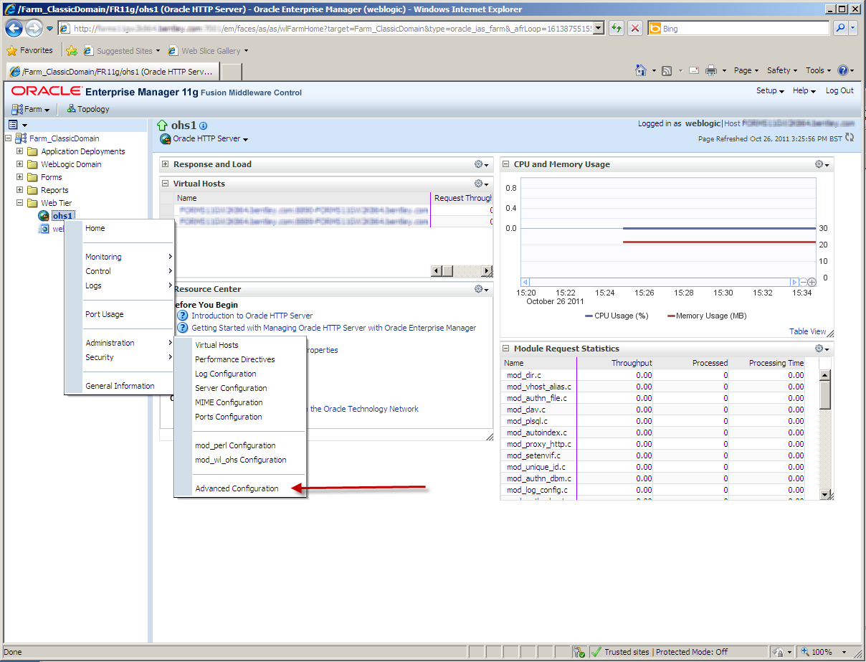

In the Advanced Server Configuration page select ‘dads.conf’ from the drop down list:

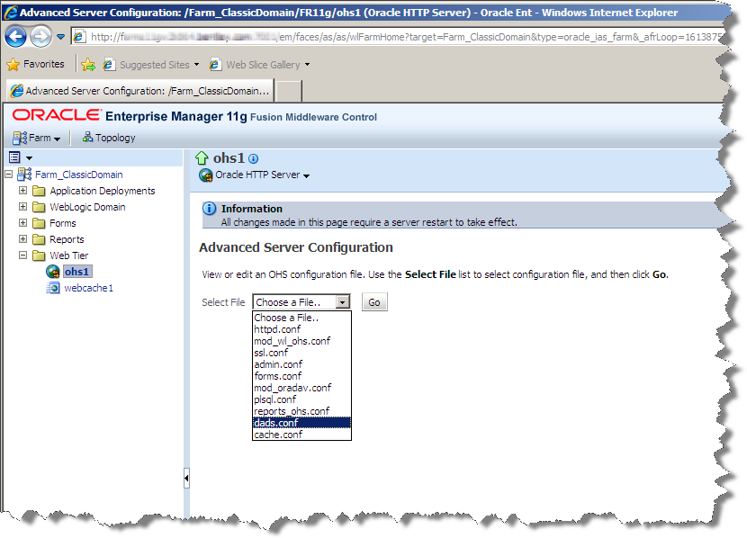

Add an entry entering the {database_name}, {PlsqlDatabaseConnectString}, {PlsqlDatabaseUsername} and {DatabasePassword}:

<Location /{database_name}/apex>

Order deny,allow

PlsqlDocumentPath docs

AllowOverride None

PlsqlDocumentProcedure wwv_flow_file_mgr.process_download

PlsqlDatabaseConnectString {PlsqlDatabaseConnectString} ServiceNameFormat

PlsqlNLSLanguage AMERICAN_AMERICA.AL32UTF8

PlsqlAuthenticationMode Basic

SetHandler pls_handler

PlsqlDocumentTablename wwv_flow_file_objects$

PlsqlDatabaseUsername {PlsqlDatabaseUsername}

PlsqlDefaultPage apex

PlsqlDatabasePassword {DatabasePassword}

PlsqlRequestValidationFunction wwv_flow_epg_include_modules.authorize

Allow from all

</Location>

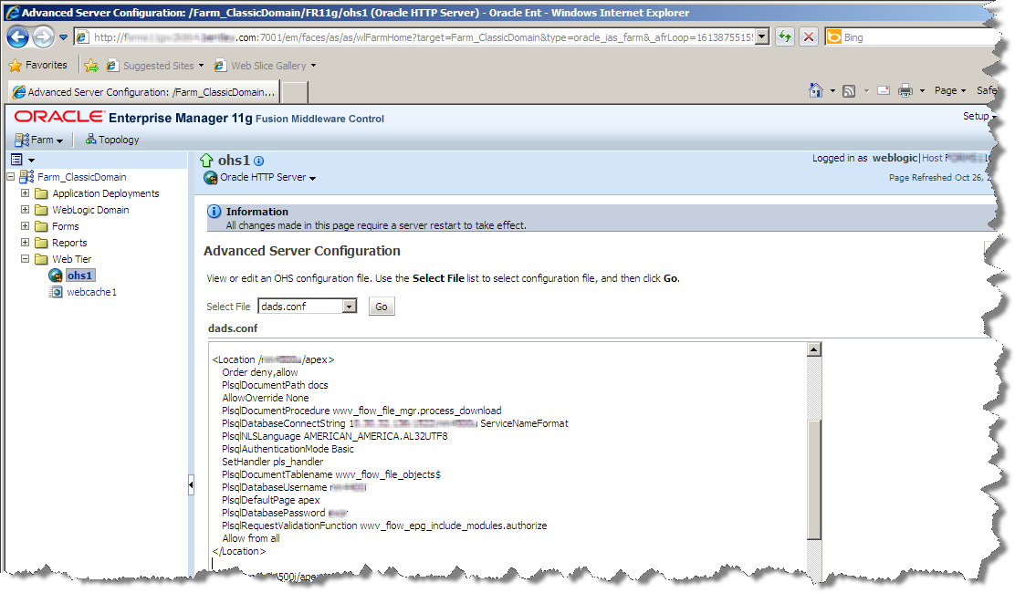

For example if the

* database name was DB4700
* connect string was 192.192.192.192:1522/DB4700
* database username (highways owner) was HIGHWAYS
* database password was HIGHWAYS

The DAD entry would look something like this:

<Location /DB4700/apex>

Order deny,allow

PlsqlDocumentPath docs

AllowOverride None

PlsqlDocumentProcedure wwv_flow_file_mgr.process_download

PlsqlDatabaseConnectString 192.192.192.192:1522/DB4700 ServiceNameFormat

PlsqlNLSLanguage AMERICAN_AMERICA.AL32UTF8

PlsqlAuthenticationMode Basic

SetHandler pls_handler

PlsqlDocumentTablename wwv_flow_file_objects$

PlsqlDatabaseUsername HIGHWAYS

PlsqlDefaultPage apex

PlsqlDatabasePassword HIGHWAYS

PlsqlRequestValidationFunction wwv_flow_epg_include_modules.authorize

Allow from all

</Location>

Ensure, also, that the Alias images string is set correctly to the location of the ApEx image files. The location should be something like this: C:\Oracle\Middleware\instances\FR11g\config\OHS\ohs1\Apex\images

Using the example location above setting the location of the images requires that the following entries are added to the dads.conf file and apply the changes.

Alias /i/ "C:\Oracle\Middleware\instances\FR11g\config\OHS\ohs1\Apex\images/"

AddType text/xml xbl

AddType text/x-component htc

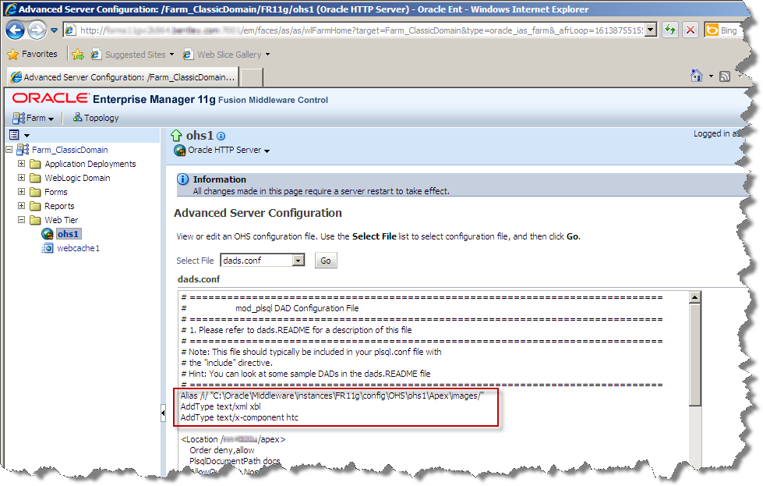

#### Restart the HTTP server

Once the DAD file has been saved the HTTP server should be restarted to pick up the changes:

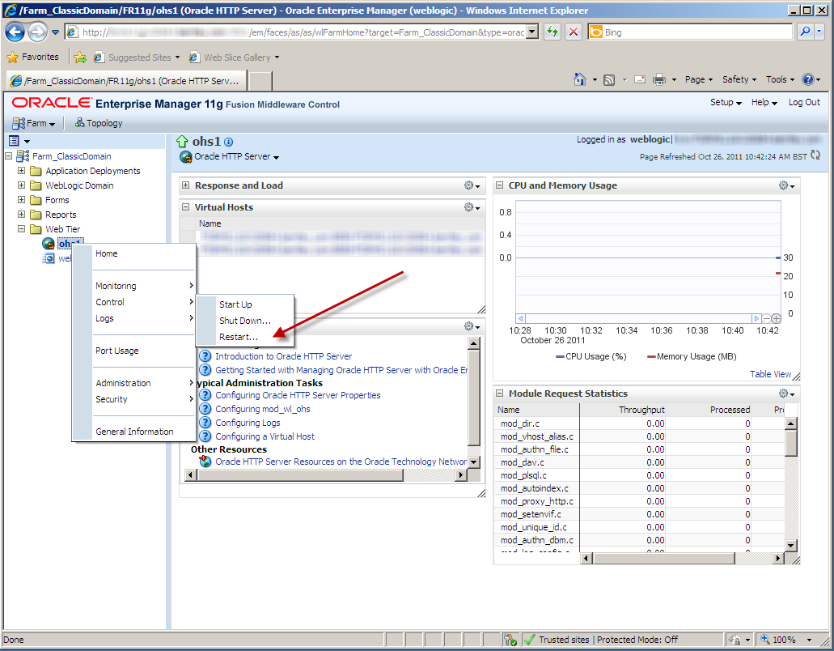

#### ApEx Admin Account

You should be able to connect to the ApEx admin account using the DAD entry created above.

ApEx Admin Connection string:

http://{11g Application Server Name}:{port number}/{location string of the DAD}/apex_admin

Using the examples above the connection string required to connect to ApEx should be (and hypothetical Application Server name and port being myAppServer:8888):

<http://myAppServer:8888/DB4700/apex/apex_admin>

Log onto the ApEx administration account:

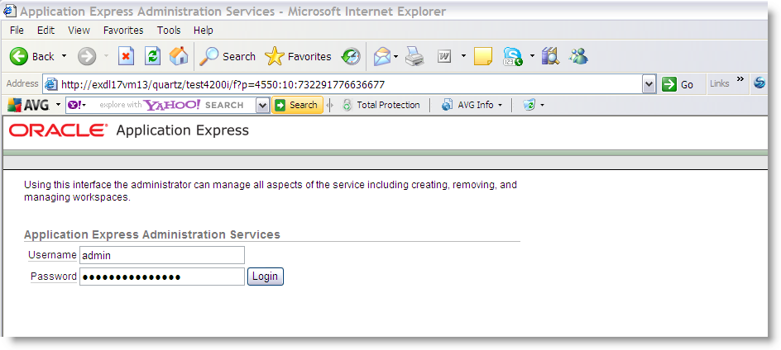

Choose ‘Manage Workspaces’ using the button or tab:

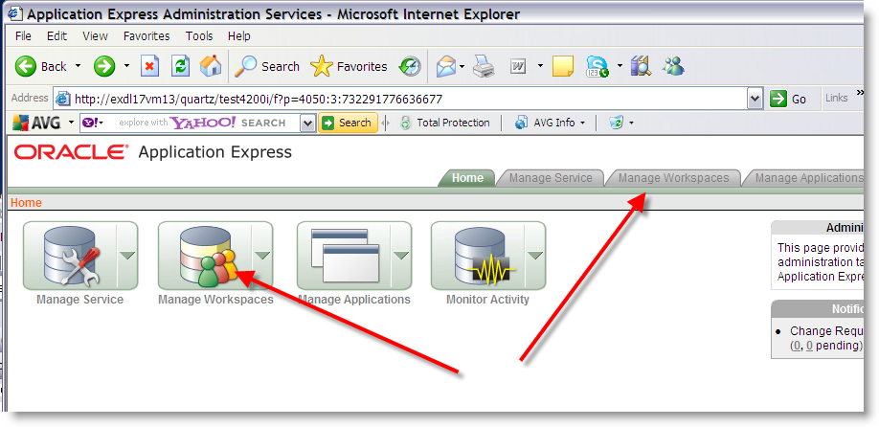

Choose the ‘Import Workspace’ hyperlink:

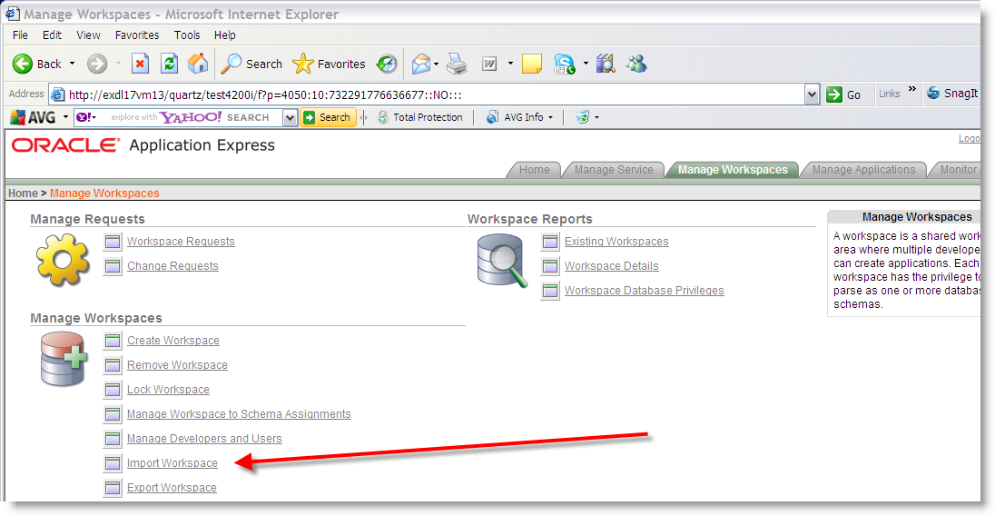

Browse for the workspace to be imported which will exist in the <exor_base>/tma/admin/sql/ directory as extracted from the zip file. The workspace is called tma_apex_rpts_workspace.sql:

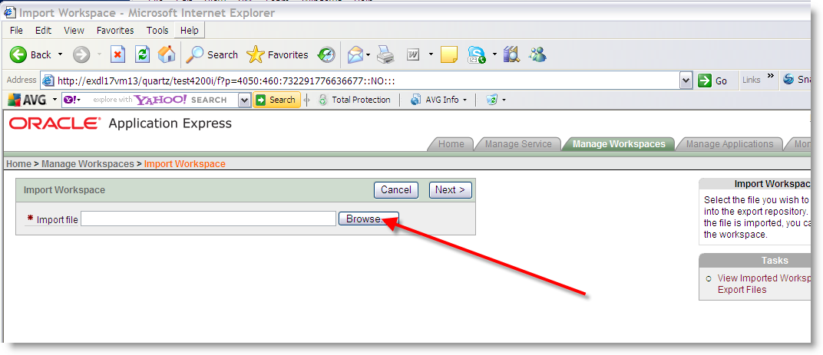

Once selected click the ‘Next’ button:

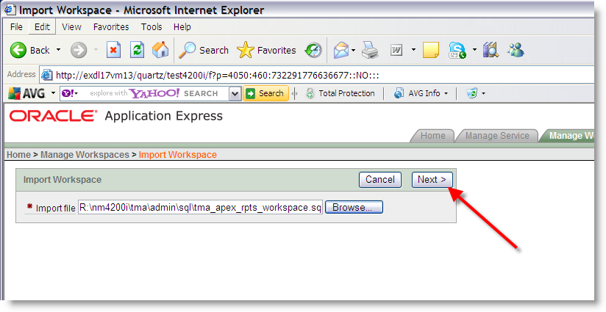

When imported successfully, as highlighted in the screenshot below, click the ‘Install’ button:

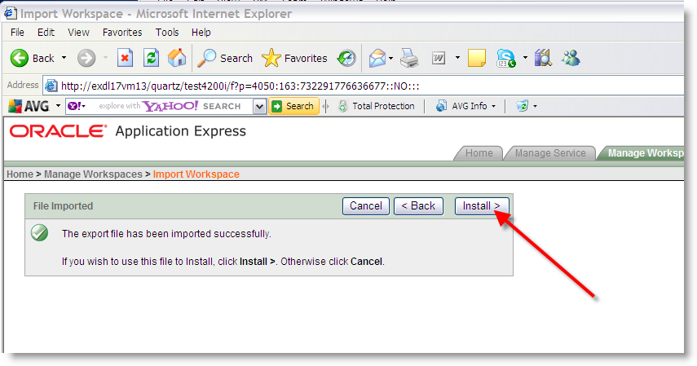

Choose to ‘Re-use existing schema?’, as highlighted by option 1 in the screenshot and then enter or select the highways schema name from the LoV as highlighted by option 2 in the screenshot.

Click the ‘Next’ button when the above is completed:

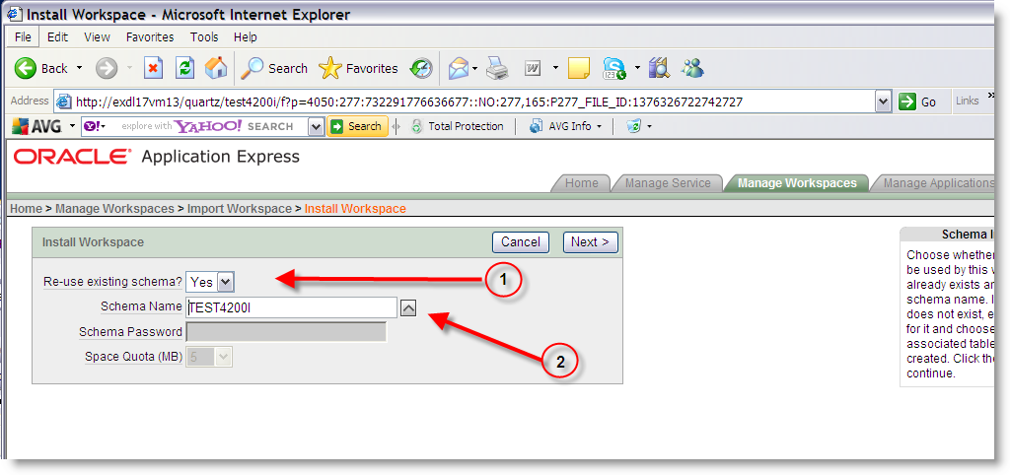

Check the ‘Check to proceed …’ check box and click the ‘Next’ button to proceed:

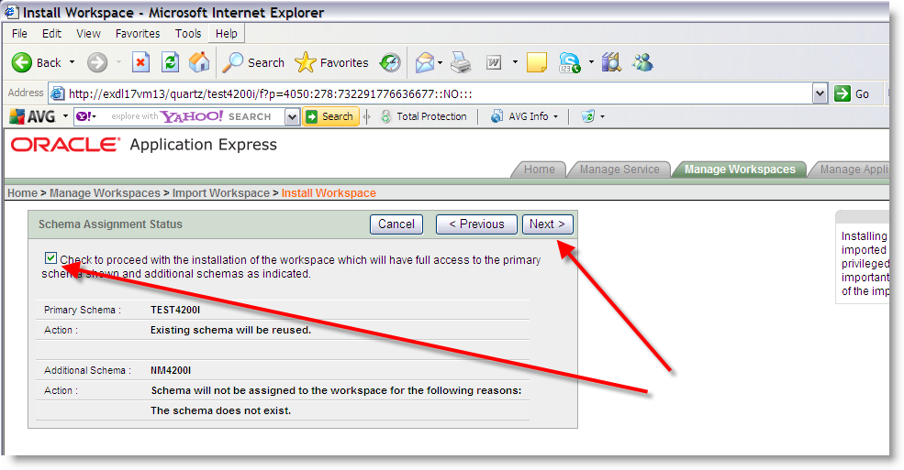

Click the ‘Install Workspace’ button:

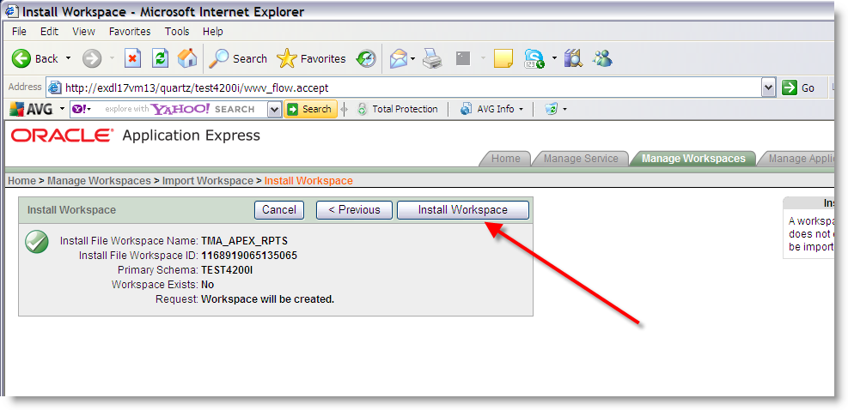

The tma_apex_rpts workspace is now installed.

Select the ‘Manage Workspaces’ tab to amend some of the user settings:

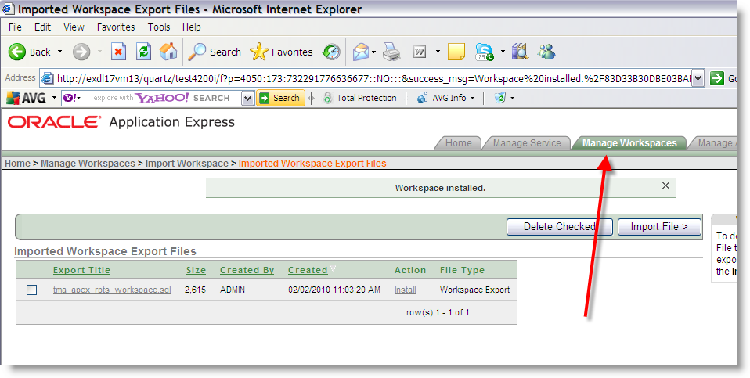

Select the ‘Manage Developers and Users’ hyperlink:

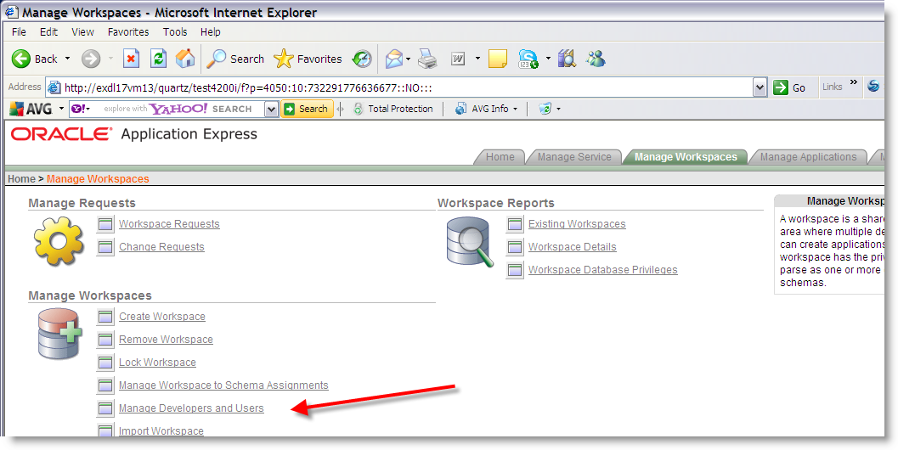

Select the ‘Admin’ user account hyperlink (for TMA_APEX_RPTS workspace):

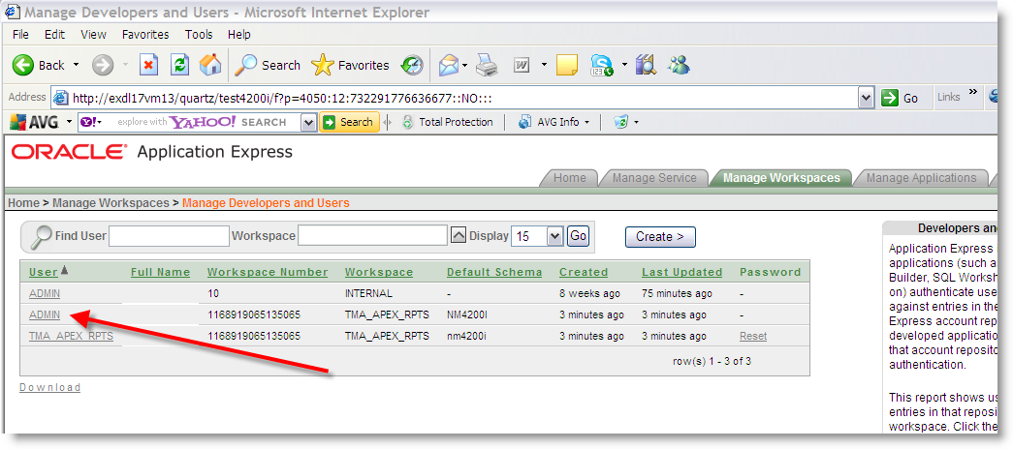

Set the ‘Email Address’ to the email address of the ApEx administrator, as highlighted in option 1 of the screenshot.

Enter the ‘Default Schema’ as the highways schema, as highlighted in option 2 of the screenshot.

When the above is completed press the ‘Apply Changes’ button:

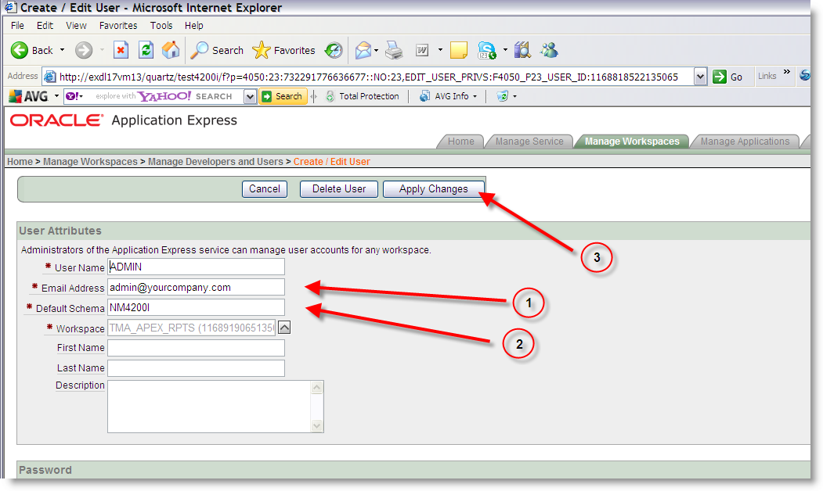

Select the ‘TMA_APEX_RPTS’ user account hyperlink:

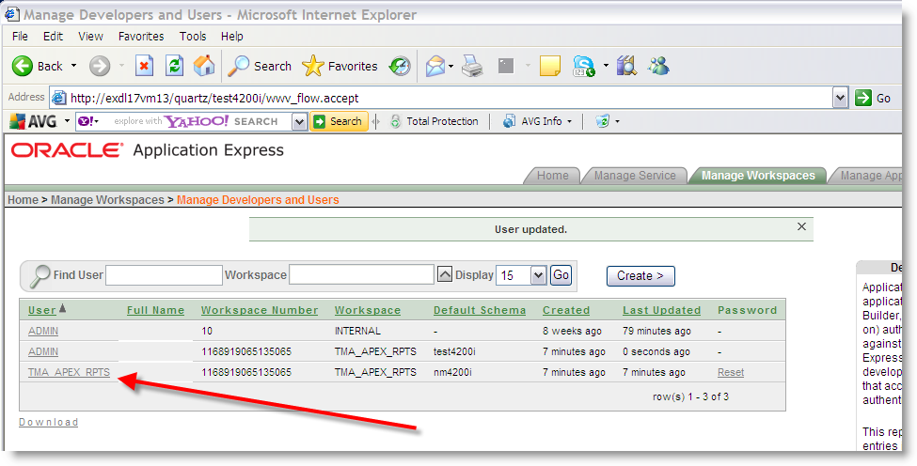

Set the ‘Email Address’ to the email address of the ApEx administrator, as highlighted in option 1 of the screenshot.

Enter the ‘Default Schema’ as the highways schema, as highlighted in option 2 of the screenshot.

When the above is completed press the ‘Apply Changes’ button:

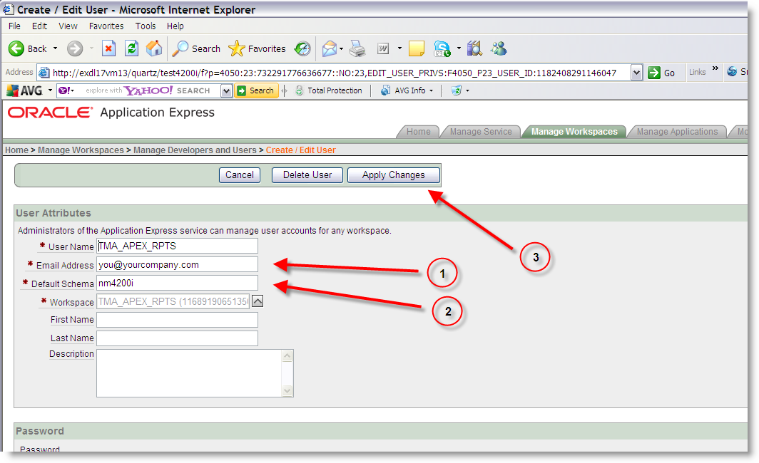

Logout of the ApEx administrator’s account and proceed with the Install of TMA Manager:

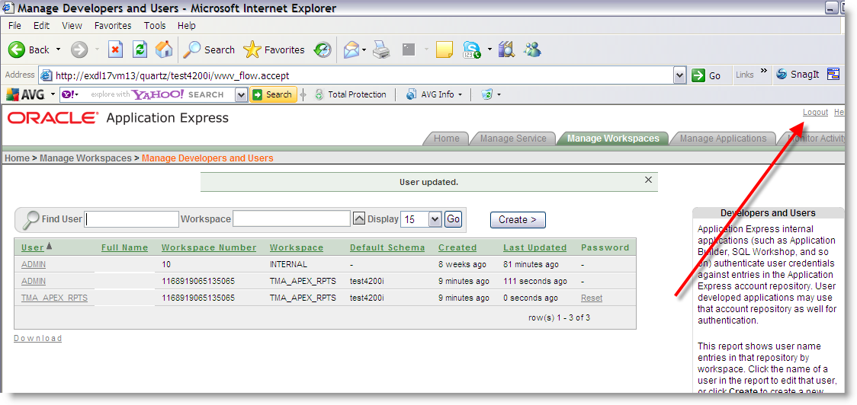

### Install of TMA Manager

To create the base data and objects for TMA Manager modules;

Change directory to <exor_base>\tma\install

Login to SQL*PLUS as the highways owner on the client PC and run the following command:

  start tma_inst.sql

You will be prompted to enter the path of the location of your highways software. This should be name of the directory, including disk identifier and a trailing slash character, referred to as <exor_base>.

For example, if you installed your highways software in a directory called EXOR on your C drive, you would enter the following when prompted.

 C:\EXOR\

When you have supplied this value, you will be prompted to confirm that it is correct and asked whether you wish to continue.

If the value specified is not correct or does not end with a slash character, you will be given an error message and the installation script will abort. You will then need to login to SQL*PLUS again and rerun the script.

When the script has completed, all the TMA Manager objects and data will have been installed.

#### Checking Log File(s)

The following log files are produced in the working directory. At the end of the installation, the files can be viewed to check for any errors that could have occurred during installation.

tma_install_1_<date&time>.LOG

tma_install_2_<date&time>.LOG

Please raise and attach the logs to a ticket with <http://selectservices.bentley.com> to allow Bentley (formerly exor) support staff to verify the install has been successful.

### Upgrade of TMA Manager

This section describes the steps necessary to upgrade TMA Manager to 4.7.0.

To upgrade the base data and objects for the TMA Manager modules;

* Change directory to <exor_base>\tma\install
* Login to SQL*PLUS as the highways owner on the client PC
* Run the following command start tma4510_tma4700.sql
* You will be prompted to enter the path of the location of your highways software. This should be name of the directory, including disk identifier and a trailing slash character, referred to as <exor_base>.
* For example, if you installed your highways software in a directory called EXOR on your C drive, you would enter the following when prompted.

C:\EXOR\

* When you have supplied this value, you will be prompted to confirm that it is correct and asked whether you wish to continue.
* If the value specified is not correct or does not end with a slash character, you will be given an error message and the installation script will abort. You will then need to login to SQL*PLUS again and rerun the script.
* When the script has completed, all the TMA Manager objects and data will have been upgraded.

#### Checking Log File(s)

The following log files are produced in the working directory. At the end of the upgrade, they can be viewed to check for any errors that could have occurred during the upgrade process.

tma4510_tma4700_1_<date&time>.LOG

tma4510_tma4700_2_<date&time>.LOG

Please raise and attach the logs to a ticket with <http://selectservices.bentley.com> to allow Bentley (formerly exor) support staff to verify the upgrade has been successful.

Due to interdependencies between some Exor products, please ignore all compilation errors until all of your products have been upgraded.

### Mandatory Configuration (Post Install and Upgrade)

#### exor_version.txt

Before accessing TMA Manager you must check the file exor_version.txt.

This file is referenced in Windows Registry setting ‘EXOR_VERSION’ and by default can be located in the <exor_base>\11g_bin directory.

Ensure that the entry for TMA Manager is set accordingly;

TMA=4.7.0.1

### Product Licencing (Post Install only)

Following first time installation you must licence the product for use.

To do this start highways by exor and invoke module HIG1890 from the Fastpath menu.



For further details please refer to the “Network Manager General System Admin Guide”

### Web Service Install/Upgrade (Post Install and Upgrade)

After a successful install/upgrade of TMA Manager to version 4.7.0 the TMA Web Service will require installation/upgrade.

Specific information regarding the installation or upgrade of the TMA Web Service can be found in the “4.7.0_TMA_EToN_Web_Service_Deployment_Guide.pdf” contained in the TMAWebService_04070001en.zip located in the <exor_base>\EToNWebService\doc\ directory.

### TMA Process Types (Install only)

For customers that have upgraded, no new TMA process types have been introduced at this release so the following instructions are for new installations of TMA Manager only.

#### Following the Install of TMA v4.7.0.

An Administrator must submit a Process of each relevant type to the desired frequency.

For example:

When the TMA1000-Works form (and other key forms are opened) a check has always been carried out to see if TMA is correctly configured.

The check will look for the existence of a process of each given type.

| Process Type | Checking Rule |
| --- | --- |
| TMA Receive Transactions | Mandatory - always checked for |
| TMA Send Transactions | Mandatory - always checked for |
| TMA Housekeeping | Mandatory - always checked for |
| TMA Reset Forwarding Errors | Only checked for if product option 'FWD_NOTICE' = ‘Y’ |
| TMA Upload Inspections | Only checked for if product option 'INSPAUTIMP ' = ‘Y’ |
| TMA Evaluate Applied Notices | Mandatory - always checked for |

If the process is expected to exist and it’s either missing or is neither ‘Running’ nor ‘Scheduled’, an error will be flagged.

### System Holidays (Post Install and Upgrade)

After install/upgrade to 4.7.0.0 has been completed please ensure that the holidays of the system have been set before using TMA Manager.

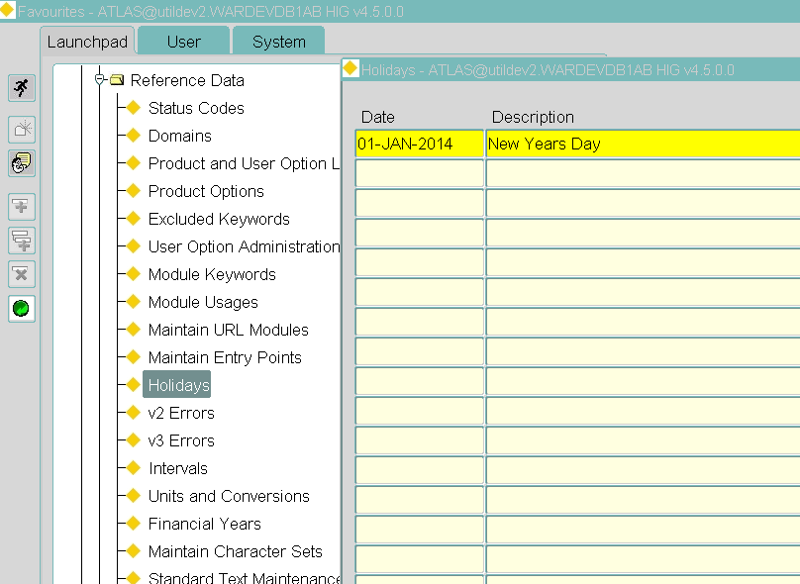

# Streetworks Manager

## Implementation of the Streetworks Manager Software files

To install the software components for Streetworks Manager first check that the SWR folder is present and correctly unzipped from the release zip file.

Important:

All exor applications that you install must go into the same destination – what is often referred to as <exor_base>.

## Streetworks Manager Server Install/Upgrade

This chapter provides details of steps involved in installing/upgrading the server components for Streetworks Manager.

Important:

This product will require installing/upgrading after Network Manager and Street Gazetteer Manager.

### Before you Start

Before proceeding please ensure that the pre-requisites mentioned in Section 2.3 of this document are met.

Also, please be aware of the following;

Where instructed to change to a directory before running a script, it is assumed that you are running SQL*PLUS from a DOS Command prompt.

If you are running SQL*PLUS in windows you should set the 'start in' directory of the SQL*PLUS shortcut to simulate the change of directory.

If you do not run SQL*PLUS from the directory stated in each step of the guide, the installation will fail.

Also, whilst following the instructions in this section you will be required to know the location of <exor_base>. You may recall that whilst undertaking the tasks in the previous subsection you will have implemented software into the location referred to as <exor_base>, for example, C:\EXOR.

### Typical problems that you may encounter

It is possible that, when you are running some of the upgrade scripts, errors may be reported saying that objects already exist in the database or that columns already exist on tables. These errors can generally be ignored. If you are in any doubt, please contact the Exor support desk for guidance.

The upgrade procedures will also attempt to install database roles in the highways owner account that are necessary for the system to operate correctly. You may find that errors are produced when running the upgrade scripts to the effect that the role names being created are already used by existing roles or users. These errors can be ignored as they simply mean that the roles being created already exist.

Also during install/upgrade Warning messages may appear saying that compilation errors have occurred. These warnings can be ignored, since invalid objects will be recompiled prompt later on in the install/upgrade. However it will be of concern if compilation errors still occur following the re-compilation.

### Install of Streetworks Manager

To create the base data and objects for Streetworks Manager modules;

Change directory to <exor_base>\swr\install

Login to SQL*PLUS as the highways owner on the client PC and run the following command:

  start swr_inst.sql

You will be prompted to enter the path of the location of your highways software. This should be name of the directory, including disk identifier and a trailing slash character, referred to as <exor_base>.

For example, if you installed your highways software in a directory called EXOR on your C drive, you would enter the following when prompted.

C:\EXOR\

When you have supplied this value, you will be prompted to confirm that it is correct and asked whether you wish to continue.

If the value specified is not correct or does not end with a slash character, you will be given an error message and the installation script will abort. You will then need to login to SQL*PLUS again and rerun the script.

When the script has completed, all the Enquiry Manager objects and data will have been installed.

### Checking Log File(s)

The following log files are produced in the working directory. At the end of the installation, the files can be viewed to check for any errors that could have occurred during installation.

swr_install_1_<date&time>.LOG

swr_install_2_<date&time>.LOG

Please raise and attach the logs to a ticket with <http://selectservices.bentley.com> to allow Bentley (formerly exor) support staff to verify the install has been successful.

### Upgrade of Streetworks Manager

This section describes the steps necessary to upgrade Streetworks Manager to 4.7.0.0

To upgrade the base data and objects for the Enquiry Manager modules;

* Change directory to <exor_base>\pem\install
* Login to SQL*PLUS as the highways owner on the client PC
* Run one the following command

start swr4500_swr4700.sql

* You will be prompted to enter the path of the location of your highways software. This should be name of the directory, including disk identifier and a trailing slash character, referred to as <exor_base>.

For example, if you installed your highways software in a directory called EXOR on your C drive, you would enter the following when prompted.

C:\EXOR\

* When you have supplied this value, you will be prompted to confirm that it is correct and asked whether you wish to continue.
* If the value specified is not correct or does not end with a slash character, you will be given an error message and the installation script will abort. You will then need to login to SQL*PLUS again and rerun the script.
* When the script has completed, all the Streetworks Manager objects and data will have been upgraded.

### Checking Log File(s)

The following log files are produced in the working directory. At the end of the upgrade, they can be viewed to check for any errors that could have occurred during the upgrade process.

swr4500_swr4700_1_<date&time>.LOG

swr_4500_swr4700_2_<date&time>.LOG

Please raise and attach the logs to a ticket with <http://selectservices.bentley.com> to allow Bentley (formerly exor) support staff to verify the upgrade has been successful.

Due to interdependencies between some Exor products, please ignore all compilation errors until all of your products have been upgraded.

### Mandatory Configuration (Post Install and Upgrade)

#### exor_version.txt

Before accessing Enquiry Manager you must check the file exor_version.txt.

This file is referenced in Windows Registry setting ‘EXOR_VERSION’ and by default can be located in the <exor_base>\11g_bin directory.

Ensure that the entry for Streetworks Manager is set accordingly;

SWR=4.7.0.0

### Additional Configuration (Post Install and Upgrade)

Consult the documentation that accompanies this release for details of any additional configuration that may be required following an install/upgrade.

For example, to obtain details of product options, and for details of new product features/amendments.

Important:

It is highly recommended that you do this before attempting to use the application.

### Product Licencing (Post Install only)

Following first time installation you must licence the product for use.

To do this start highways by exor and invoke module HIG1890 from the Fastpath menu.



For further details please refer to the “Network Manager General System Admin Guide”

### Spatial Configuration (Post Install and Upgrade)

Specific information regarding the registration of spatial layers can be found in the “Locator and Web Mapping” document.

# Asset Valuation Manager

## Implementation of the Asset Valuation Manager Software files

To install the software components for Asset Valuation Manager first check that the AVM folder is present and correctly unzipped from the release zip file.

**Important:**

All exor applications that you install must go into the same destination – what is often referred to as **<exor_base>**.

## Asset Valuation Manager Server Install/Upgrade

This chapter provides details of steps involved in installing/upgrading the server components for Asset

Valuation Manager.

**Important:**

This product will require installing/upgrading ***after*** Network Manager.

### **Before you Start**

Before proceeding please ensure that the pre-requisites mentioned in **Section 2.3** of this document are met.

Also, please be aware of the following;

Where instructed to change to a directory before running a script, it is assumed that you are running SQL*PLUS from a DOS Command prompt.

If you are running SQL*PLUS in windows you should set the 'start in' directory of the SQL*PLUS shortcut to simulate the change of directory.

**If you do not run SQL*PLUS from the directory stated in each step of the guide, the installation will fail.**

Also, whilst following the instructions in this section you will be required to know the location of **<exor_base>.** You may recall that whilst undertaking the tasks in the previous subsection you will have implemented software into the location referred to as **<exor_base>**, for example, C:\EXOR.

### **Typical problems that you may encounter**

It is possible that, when you are running some of the upgrade scripts, errors may be reported saying that objects already exist in the database or that columns already exist on tables. These errors can generally be ignored. If you are in any doubt, please contact the Exor support desk for guidance.

The upgrade procedures will also attempt to install database roles in the highways owner account that are necessary for the system to operate correctly. You may find that errors are produced when running the upgrade scripts to the effect that the role names being created are already used by existing roles or users. These errors can be ignored as they simply mean that the roles being created already exist.

Also during install/upgrade Warning messages may appear saying that compilation errors have occurred. These warnings can be ignored, since invalid objects will be recompiled prompt later on in the install/upgrade. However it will be of concern if compilation errors still occur following the re-compilation.

### **Install of Asset Valuation Manager**

To create the base data and objects for Asset Valuation Manager modules;

Change directory to **<exor_base>**\avm\install

Login to SQL*PLUS as the highways owner on the client PC and run the following command:

start vm_inst.sql

You will be prompted to enter the path of the location of your highways software. This should be name of the directory, including disk identifier and a trailing slash character, referred to as <exor_base>.

For example, if you installed your highways software in a directory called EXOR on your C drive, you would enter the following when prompted.

C:\EXOR\

When you have supplied this value, you will be prompted to confirm that it is correct and asked whether you wish to continue.

If the value specified is not correct or does not end with a slash character, you will be given an error message and the installation script will abort. You will then need to login to SQL*PLUS again and rerun the script.

When the script has completed, all the Asset Valuation Manager objects and data will have been installed.

**Checking Log File(s)**

The following log files are produced in the working directory. At the end of the installation, the files can be viewed to check for any errors that could have occurred during installation.

vm_install_1_<**date&time**>.LOG

vm_install_2_<**date&time**>.LOG

Please raise and attach the logs to a ticket with <http://selectservices.bentley.com> to allow Bentley (formerly exor) support staff to verify the install has been successful.

### **Upgrade of Asset Valuation Manager**

This section describes the steps necessary to upgrade Asset Valuation Manager to 4.7.0.0.

To upgrade the base data and objects for the Asset Valuation Manager modules;

Change directory to **<exor_base>**\avm\install

Login to SQL*PLUS as the highways owner on the client PC

Run the following command

start avm4500_avm4700.sql

You will be prompted to enter the path of the location of your highways software. This should be name of the directory, including disk identifier and a trailing slash character, referred to as **<exor_base>**.

For example, if you installed your highways software in a directory called EXOR on your C drive, you would enter the following when prompted.

C:\EXOR\

When you have supplied this value, you will be prompted to confirm that it is correct and asked whether you wish to continue.

If the value specified is not correct or does not end with a slash character, you will be given an error message and the installation script will abort. You will then need to login to SQL*PLUS again and rerun the script.

When the script has completed, all the Asset Valuation Manager objects and data will have been upgraded.

**Checking Log File(s)**

The following log files are produced in the working directory. At the end of the upgrade, they can be viewed to check for any errors that could have occurred during the upgrade process.

avm4500_avm4700_1_<**date&time**>.LOG

avm4500_avm4700_2_<**date&time**>.LOG

Please raise and attach the logs to a ticket with <http://selectservices.bentley.com> to allow Bentley (formerly exor) support staff to verify the upgrade has been successful.

Due to interdependencies between some Exor products, please ignore all compilation errors until all of your products have been upgraded.

### **Mandatory Configuration (Post Install and Upgrade)**

**exor_version.txt**

Before accessing Asset Valuation Manager you must check the file exor_version.txt.

This file is referenced in Windows Registry setting ‘EXOR_VERSION’ and by default can be located in the **<exor_base>**\bin directory.

Ensure that the entry for Asset Valuation Manager is set accordingly;

**AVM=4.7.0.1**

### **Product Licensing (Post Install only)**

Following first time installation you must license the product for use.

To do this start highways by exor and invoke module **HIG1890** from the **Fastpath** menu.



For further details please refer to the “**Network Manager General System Admin Guide**”.

### **Additional Configuration (Post Install and Upgrade)**

Consult the documentation that accompanies this release for details of any additional configuration that may be required following an install/upgrade.

For example, to obtain details of product options, and for details of new product features/amendments.

**Important:**

It is highly recommended that you do this before attempting to use the application.

# Accidents Manager

## Implementation of the Accidents Manager Software files

To install the software components for Accidents Manager extract the ACC files from the zip file into a working directory e.g. C:\EXOR to be referred to as <exor_base>.

### Before You Start

Before proceeding please ensure that the pre-requisites mentioned in Section 2.3 of this document are met.

Also please be aware of the following;

Where instructed to change to a directory before running a script, it is assumed that you are running SQL*PLUS from a DOS Command prompt.

If you are running SQL*PLUS in windows you should set the 'start in' directory of the SQL*PLUS shortcut to simulate the change of directory.

If you do not run SQL*PLUS from the directory stated in each step of the guide, the installation will fail.

Also, whilst following the instructions in this section you will be required to know the location of <exor_base>. You may recall that whilst undertaking the tasks in Chapter 2 you will have installed software into the location referred to as <exor_base>, for example, C:\EXOR.

### Typical Problems That You May Encounter

It is possible that, when you are running some of the upgrade scripts, errors may be reported saying that objects already exist in the database or that columns already exist on tables. These errors can generally be ignored. If you are in any doubt, please contact the Exor support desk for guidance.

The upgrade procedures will also attempt to install database roles in the highways owner account that are necessary for the system to operate correctly. You may find that errors are produced when running the upgrade scripts to the effect that the role names being created are already used by existing roles or users. These errors can be ignored as they simply mean that the roles being created already exist.

Also during install/upgrade Warning messages may appear saying that compilation errors have occurred. These warnings can be ignored, since invalid objects will be recompiled prompt later on in the install/upgrade. However it will be of concern if compilation errors still occur following the re-compilation.

### Installation of Accidents Manager

To create the base data and objects for Accidents Manager modules;

Change directory to <exor_base>\acc\install

Login to SQL*PLUS as the highways owner on the client PC and run the following command:

start acc_inst

You will be prompted to enter the path of the location of your highways software. This should be name of the directory, including disk identifier and a trailing slash character, referred to as <exor_base>.

For example, if you installed your highways software in a directory called EXOR on your C drive, you would enter the following when prompted.

C:\EXOR\

When you have supplied this value, you will be prompted to confirm that it is correct and asked whether you wish to continue.

If the value specified is not correct or does not end with a slash character, you will be given an error message and the installation script will abort. You will then need to login to SQL*PLUS again and rerun the script.

When the script has completed, all the Accidents Manager objects and data will have been installed.

Checking Log File(s)

The following log files are produced in the working directory. At the end of the installation, the files can be viewed to check for any errors that could have occurred during installation.

acc_install_1_<date&time>.LOG

acc_install_2_<date&time>.LOG

Note:

Log files should be emailed to [support@bentley.com](mailto:support@bentley.com) to allow Bentley support staff to verify the install has been successful.

### Upgrade of Accidents Manager

This section describes the steps necessary to upgrade Accidents Manager to 4.7.0.0

To upgrade the base data and objects for the Accidents Manager modules;

Change directory to <exor_base>\acc\install

Login to SQL*PLUS as the highways owner on the client PC

Run the following command

start acc4500_acc4700.sql

You will be prompted to enter the path of the location of your highways software. This should be name of the directory, including disk identifier and a trailing slash character, referred to as <exor_base>.

For example, if you installed your highways software in a directory called EXOR on your C drive, you would enter the following when prompted.

C:\EXOR\

When you have supplied this value, you will be prompted to confirm that it is correct and asked whether you wish to continue.

If the value specified is not correct or does not end with a slash character, you will be given an error message and the installation script will abort. You will then need to login to SQL*PLUS again and rerun the script.

When the script has completed, all the Accidents Manager objects and data will have been upgraded.

### Checking Log File(s)

The following log files are produced in the working directory. At the end of the upgrade, they can be viewed to check for any errors that could have occurred during the upgrade process.

acc4500_acc4700_1_<date&time>.LOG

acc4500_acc4700_2_<date&time>.LOG

Log files should be emailed to [support@bentley.com](mailto:support@bentley.com) to allow Bentley support staff to verify the upgrade has been successful.

### Post Install/Upgrade Tasks

Before accessing Accidents Manager you must check the file exor_version.txt.

This file is referenced in Windows Registry setting ‘EXOR_VERSION’ and by default can be located in the <exor_base>\bin directory.

Ensure that the entry for Accidents Manager is set accordingly;

ACC=4.7.0.0

# Public Rights of Way Manager

## Implementation of the Public Rights of Way Manager Software files

To install the software components for Public Rights of Way Manager first check that the PROW folder is present and correctly unzipped from the release zip file.

Important:

All exor applications that you install must go into the same destination – what is often referred to as <exor_base>.

## Public Rights of Way Manager Server Install/Upgrade

This chapter provides details of steps involved in installing/upgrading the server components for Public Rights of Way Manager.

Important:

This product will require installing/upgrading after Network Manager.

This product also has dependencies on Public Enquiry Manager and Maintenance Manager so they must be installed/upgraded before you begin this install/upgrade.

### Before you Start

Before proceeding please ensure that the pre-requisites mentioned in Section 2.3 of this document are met.

Also, please be aware of the following;

Where instructed to change to a directory before running a script, it is assumed that you are running SQL*PLUS from a DOS Command prompt.

If you are running SQL*PLUS in windows you should set the 'start in' directory of the SQL*PLUS shortcut to simulate the change of directory.

If you do not run SQL*PLUS from the directory stated in each step of the guide, the installation will fail.

Also, whilst following the instructions in this section you will be required to know the location of <exor_base>. You may recall that whilst undertaking the tasks in the previous subsection you will have implemented software into the location referred to as <exor_base>, for example, C:\EXOR.

### Typical problems that you may encounter

It is possible that, when you are running some of the upgrade scripts, errors may be reported saying that objects already exist in the database or that columns already exist on tables. These errors can generally be ignored. If you are in any doubt, please contact the Exor support desk for guidance.

The upgrade procedures will also attempt to install database roles in the highways owner account that are necessary for the system to operate correctly. You may find that errors are produced when running the upgrade scripts to the effect that the role names being created are already used by existing roles or users. These errors can be ignored as they simply mean that the roles being created already exist.

Also during install/upgrade Warning messages may appear saying that compilation errors have occurred. These warnings can be ignored, since invalid objects will be recompiled prompt later on in the install/upgrade. However it will be of concern if compilation errors still occur following the re-compilation.

### Install of Public Rights of Way Manager

To create the base data and objects for Public Rights of Way Manager modules;

Change directory to <exor_base>\prow\install

Login to SQL*PLUS as the highways owner on the client PC and run the following command:

  start prow_inst.sql

You will be prompted to enter the path of the location of your highways software. This should be name of the directory, including disk identifier and a trailing slash character, referred to as <exor_base>.

For example, if you installed your highways software in a directory called EXOR on your C drive, you would enter the following when prompted.

 C:\EXOR\

When you have supplied this value, you will be prompted to confirm that it is correct and asked whether you wish to continue.

If the value specified is not correct or does not end with a slash character, you will be given an error message and the installation script will abort. You will then need to login to SQL*PLUS again and rerun the script.

When the script has completed, all the Public Rights of Way Manager objects and data will have been installed.

### Checking Log File(s)

The following log files are produced in the working directory. At the end of the installation, the files can be viewed to check for any errors that could have occurred during installation.

  prow_install_1_<date&time>.LOG

  prow_install_2_<date&time>.LOG

Please raise and attach the logs to a ticket with <http://selectservices.bentley.com> to allow Bentley (formerly exor) support staff to verify the install has been successful.

### Upgrade of Public Rights of Way Manager

This section describes the steps necessary to upgrade Public Rights of Way Manager to 4.7.0.0

To upgrade the base data and objects for the Public Rights of Way Manager modules;

* Change directory to <exor_base>\prow\install
* Login to SQL*PLUS as the highways owner on the client PC
* Run the following command

start prow4500_prow4700.sql

* You will be prompted to enter the path of the location of your highways software. This should be name of the directory, including disk identifier and a trailing slash character, referred to as <exor_base>.

For example, if you installed your highways software in a directory called EXOR on your C  
 drive, you would enter the following when prompted.

C:\EXOR\

* When you have supplied this value, you will be prompted to confirm that it is correct and asked whether you wish to continue.
* If the value specified is not correct or does not end with a slash character, you will be given an error message and the installation script will abort. You will then need to login to SQL*PLUS again and rerun the script.
* When the script has completed, all the Public Rights of Way Manager objects and data will have been upgraded.

### Checking Log File(s)

The following log files are produced in the working directory. At the end of the upgrade, they can be viewed to check for any errors that could have occurred during the upgrade process.

Prow4500_prow4700_1_<date&time>.LOG

Prow4500_prow4700_2_<date&time>.LOG

Please raise and attach the logs to a ticket with <http://selectservices.bentley.com> to allow Bentley (formerly exor) support staff to verify the upgrade has been successful.

Due to interdependencies between some Exor products, please ignore all compilation errors until all of your products have been upgraded.

### Mandatory Configuration (Post Install and Upgrade)

#### exor_version.txt

Before accessing Enquiry Manager you must check the file exor_version.txt.

This file is referenced in Windows Registry setting ‘EXOR_VERSION’ and by default can be located in the <exor_base>\11g_bin directory.

Ensure that the entry for Public Rights of Way Manager is set accordingly;

PROW=4.7.0.0

### Additional Configuration (Post Install and Upgrade)

Consult the documentation that accompanies this release for details of any additional configuration that may be required following an install/upgrade.

For example, to obtain details of product options, and for details of new product features/amendments.

Important:

It is highly recommended that you do this before attempting to use the application.

### Product Licencing (Post Install only)

Following first time installation you must licence the product for use.

To do this start highways by exor and invoke module HIG1890 from the Fastpath menu.



For further details please refer to the “Network Manager General System Admin Guide”

### Spatial Configuration (Post Install and Upgrade)

Specific information regarding the registration of spatial layers can be found in the “Locator and Web Mapping” document.

# Street Lighting Manager

## Implementation of the Street Lighting Manager Software files

To install the software components for Street Lighting Manager first check that the SLM folder is present and correctly unzipped from the release zip file.

**Important:**

All exor applications that you install must go into the same destination – what is often referred to as **<exor_base>**.

## Street Lighting Manager Server Install/Upgrade

This chapter provides details of steps involved in installing/upgrading the server components for Street Lighting Manager.

**Important:**

This product will require installing/upgrading ***after*** Network Manager.

### **Before you Start**

Before proceeding please ensure that the pre-requisites mentioned in **Section 2.3** of this document are met.

Also, please be aware of the following;

Where instructed to change to a directory before running a script, it is assumed that you are running SQL*PLUS from a DOS Command prompt.

If you are running SQL*PLUS in windows you should set the 'start in' directory of the SQL*PLUS shortcut to simulate the change of directory.

**If you do not run SQL*PLUS from the directory stated in each step of the guide, the installation will fail.**

Also, whilst following the instructions in this section you will be required to know the location of **<exor_base>**. You may recall that whilst undertaking the tasks in the previous subsection you will have implemented software into the location referred to as **<exor_base>**, for example, C:\EXOR.

### **Typical problems that you may encounter**

It is possible that, when you are running some of the upgrade scripts, errors may be reported saying that objects already exist in the database or that columns already exist on tables. These errors can generally be ignored. If you are in any doubt, please contact the Exor support desk for guidance.

The upgrade procedures will also attempt to install database roles in the highways owner account that are necessary for the system to operate correctly. You may find that errors are produced when running the upgrade scripts to the effect that the role names being created are already used by existing roles or users. These errors can be ignored as they simply mean that the roles being created already exist.

Also during install/upgrade Warning messages may appear saying that compilation errors have occurred. These warnings can be ignored, since invalid objects will be recompiled prompt later on in the install/upgrade. However it will be of concern if compilation errors still occur following the re-compilation.

### **Install of Street Lighting Manager**

To create the base data and objects for Street Lighting Manager modules;

Change directory to **<exor_base>**\slm\install

Login to SQL*PLUS as the highways owner on the client PC and run the following command:

start slm_inst.sql

You will be prompted to enter the path of the location of your highways software. This should be name of the directory, including disk identifier and a trailing slash character, referred to as <exor_base>.

For example, if you installed your highways software in a directory called EXOR on your C drive, you would enter the following when prompted.

C:\EXOR\

When you have supplied this value, you will be prompted to confirm that it is correct and asked whether you wish to continue.

If the value specified is not correct or does not end with a slash character, you will be given an error message and the installation script will abort. You will then need to login to SQL*PLUS again and rerun the script.

When the script has completed, all the Street Lighting Manager objects and data will have been installed.

**Checking Log File(s)**

The following log files are produced in the working directory. At the end of the installation, the files can be viewed to check for any errors that could have occurred during installation.

slm_install_1_<**date&time**>.LOG

slm_install_2_<**date&time**>.LOG

Please raise and attach the logs to a ticket with <http://selectservices.bentley.com> to allow Bentley (formerly exor) support staff to verify the install has been successful.

### **Upgrade of Street Lighting Manager**

This section describes the steps necessary to upgrade Street Lighting Manager to 4.7.0.0.

To upgrade the base data and objects for the Street Lighting Manager modules;

Change directory to **<exor_base>**\slm\install

Login to SQL*PLUS as the highways owner on the client PC

Run the following command

start slm4500_slm4700.sql

You will be prompted to enter the path of the location of your highways software. This should be name of the directory, including disk identifier and a trailing slash character, referred to as **<exor_base>**.

For example, if you installed your highways software in a directory called EXOR on your C drive, you would enter the following when prompted.

C:\EXOR\

When you have supplied this value, you will be prompted to confirm that it is correct and asked whether you wish to continue.

If the value specified is not correct or does not end with a slash character, you will be given an error message and the installation script will abort. You will then need to login to SQL*PLUS again and rerun the script.

When the script has completed, all the Street Lighting Manager objects and data will have been upgraded.

**Checking Log File(s)**

The following log files are produced in the working directory. At the end of the upgrade, they can be viewed to check for any errors that could have occurred during the upgrade process.

slm4500_slm4700_1_<**date&time**>.LOG

slm4500_slm4700_2_<**date&time**>.LOG

Please raise and attach the logs to a ticket with <http://selectservices.bentley.com> to allow Bentley (formerly exor) support staff to verify the upgrade has been successful.

Due to interdependencies between some Exor products, please ignore all compilation errors until all of your products have been upgraded.

### **Mandatory Configuration (Post Install and Upgrade)**

**exor_version.txt**

Before accessing Street Lighting Manager you must check the file exor_version.txt.

This file is referenced in Windows Registry setting ‘EXOR_VERSION’ and by default can be located in the **<exor_base>**\bin directory.

Ensure that the entry for Street Lighting Manager is set accordingly;

**CLM=4.7.0.1**

### **Product Licensing (Post Install only)**

Following first time installation you must license the product for use.

To do this start highways by exor and invoke module **HIG1890** from the **Fastpath** menu.



For further details please refer to the “**Network Manager General System Admin Guide**”.

### **Additional Configuration (Post Install and Upgrade)**

Consult the documentation that accompanies this release for details of any additional configuration that may be required following an install/upgrade.

For example, to obtain details of product options, and for details of new product features/amendments.

**Important:**

It is highly recommended that you do this before attempting to use the application.

# Schemes Manager

## Implementation of the Schemes Manager Software files

To install the software components for Schemes Manager first check that the STP folder is present and correctly unzipped from the release zip file.

Important:

All exor applications that you install must go into the same destination – what is often referred to as <exor_base>.

## Schemes Manager Server Install/Upgrade

This chapter provides details of steps involved in installing/upgrading the server components for Schemes Manager.

Important:

This product will require installing/upgrading after Network Manager.

### Before you Start

Before proceeding please ensure that the pre-requisites mentioned in Section 2.3 of this document are met.

Also, please be aware of the following;

Where instructed to change to a directory before running a script, it is assumed that you are running SQL*PLUS from a DOS Command prompt.

If you are running SQL*PLUS in windows you should set the 'start in' directory of the SQL*PLUS shortcut to simulate the change of directory.

If you do not run SQL*PLUS from the directory stated in each step of the guide, the installation will fail.

Also, whilst following the instructions in this section you will be required to know the location of <exor_base>. You may recall that whilst undertaking the tasks in the previous subsection you will have implemented software into the location referred to as <exor_base>, for example, C:\EXOR.

### Typical problems that you may encounter

It is possible that, when you are running some of the upgrade scripts, errors may be reported saying that objects already exist in the database or that columns already exist on tables. These errors can generally be ignored. If you are in any doubt, please contact the Exor support desk for guidance.

The upgrade procedures will also attempt to install database roles in the highways owner account that are necessary for the system to operate correctly. You may find that errors are produced when running the upgrade scripts to the effect that the role names being created are already used by existing roles or users. These errors can be ignored as they simply mean that the roles being created already exist.

Also during install/upgrade Warning messages may appear saying that compilation errors have occurred. These warnings can be ignored, since invalid objects will be recompiled prompt later on in the install/upgrade. However it will be of concern if compilation errors still occur following the re-compilation.

### Install of Schemes Manager

To create the base data and objects for Schemes Manager modules;

Change directory to <exor_base>\stp\install

Login to SQL*PLUS as the highways owner on the client PC and run the following command:

  start stp_inst.sql

You will be prompted to enter the path of the location of your highways software. This should be name of the directory, including disk identifier and a trailing slash character, referred to as <exor_base>.

For example, if you installed your highways software in a directory called EXOR on your C drive, you would enter the following when prompted.

 C:\EXOR\

When you have supplied this value, you will be prompted to confirm that it is correct and asked whether you wish to continue.

If the value specified is not correct or does not end with a slash character, you will be given an error message and the installation script will abort. You will then need to login to SQL*PLUS again and rerun the script.

When the script has completed, all the Schemes Manager objects and data will have been installed.

### Checking Log File(s)

The following log files are produced in the working directory. At the end of the installation, the files can be viewed to check for any errors that could have occurred during installation.

  stp_install_1_<date&time>.LOG

  stp_install_2_<date&time>.LOG

Please raise and attach the logs to a ticket with <http://selectservices.bentley.com> to allow Bentley (formerly exor) support staff to verify the install has been successful.

### Upgrade of Schemes Manager

This section describes the steps necessary to upgrade Schemes Manager to 4.7.0.0

To upgrade the base data and objects for the Structures Manager modules;

* Change directory to <exor_base>\stp\install
* Login to SQL*PLUS as the highways owner on the client PC
* Run one of the following commands depending on which version you are upgrading from.

For an upgrade from 4.5: start stp4500_stp4700.sql

For an upgrade from 4.6: start stp4600_stp4700.sql

* You will be prompted to enter the path of the location of your highways software. This should be name of the directory, including disk identifier and a trailing slash character, referred to as <exor_base>.

For example, if you installed your highways software in a directory called EXOR on your C  
 drive, you would enter the following when prompted.

C:\EXOR\

* When you have supplied this value, you will be prompted to confirm that it is correct and asked whether you wish to continue.
* If the value specified is not correct or does not end with a slash character, you will be given an error message and the installation script will abort. You will then need to login to SQL*PLUS again and rerun the script.
* When the script has completed, all the Schemes Manager objects and data will have been upgraded.

### Checking Log File(s)

The following log files are produced in the working directory. At the end of the upgrade, they can be viewed to check for any errors that could have occurred during the upgrade process.

stp<xx>_stp4700_1_<date&time>.LOG

stp<xx>_stp4700_2_<date&time>.LOG

where <xx> refers to the original release number (i.e. 4500, 4600)

Please raise and attach the logs to a ticket with <http://selectservices.bentley.com> to allow Bentley (formerly exor) support staff to verify the upgrade has been successful.

Due to interdependencies between some Exor products, please ignore all compilation errors until all of your products have been upgraded.

### Mandatory Configuration (Post Install and Upgrade)

#### exor_version.txt

Before accessing Enquiry Manager you must check the file exor_version.txt.

This file is referenced in Windows Registry setting ‘EXOR_VERSION’ and by default can be located in the <exor_base>\11g_bin directory.

Ensure that the entry for Enquiry Manager is set accordingly;

STP=4.7.0.0

### Additional Configuration (Post Install and Upgrade)

Consult the documentation that accompanies this release for details of any additional configuration that may be required following an install/upgrade.

For example, to obtain details of product options, and for details of new product features/amendments.

Important:

It is highly recommended that you do this before attempting to use the application.

### Product Licencing (Post Install only)

Following first time installation you must licence the product for use.

To do this start highways by exor and invoke module HIG1890 from the Fastpath menu.



For further details please refer to the “Network Manager General System Admin Guide”

### Spatial Configuration (Post Install and Upgrade)

Specific information regarding the registration of spatial layers can be found in the “Locator and Web Mapping” document.

# Structures Manager

## Implementation of the Structures Manager Software files

To install the software components for Structures Manager first check that the STR folder is present and correctly unzipped from the release zip file.

Important:

All exor applications that you install must go into the same destination – what is often referred to as <exor_base>.

## Structures Manager Server Install/Upgrade

This chapter provides details of steps involved in installing/upgrading the server components for Structures Manager.

Important:

This product will require installing/upgrading after Network Manager.

### Before you Start

Before proceeding please ensure that the pre-requisites mentioned in Section 2.3 of this document are met.

Also, please be aware of the following;

Where instructed to change to a directory before running a script, it is assumed that you are running SQL*PLUS from a DOS Command prompt.

If you are running SQL*PLUS in windows you should set the 'start in' directory of the SQL*PLUS shortcut to simulate the change of directory.

If you do not run SQL*PLUS from the directory stated in each step of the guide, the installation will fail.

Also, whilst following the instructions in this section you will be required to know the location of <exor_base>. You may recall that whilst undertaking the tasks in the previous subsection you will have implemented software into the location referred to as <exor_base>, for example, C:\EXOR.

### Typical problems that you may encounter

It is possible that, when you are running some of the upgrade scripts, errors may be reported saying that objects already exist in the database or that columns already exist on tables. These errors can generally be ignored. If you are in any doubt, please contact the Exor support desk for guidance.

The upgrade procedures will also attempt to install database roles in the highways owner account that are necessary for the system to operate correctly. You may find that errors are produced when running the upgrade scripts to the effect that the role names being created are already used by existing roles or users. These errors can be ignored as they simply mean that the roles being created already exist.

Also during install/upgrade Warning messages may appear saying that compilation errors have occurred. These warnings can be ignored, since invalid objects will be recompiled prompt later on in the install/upgrade. However it will be of concern if compilation errors still occur following the re-compilation.

### Install of Structures Manager

To create the base data and objects for Structures Manager modules;

Change directory to <exor_base>\str\install

Login to SQL*PLUS as the highways owner on the client PC and run the following command:

  start str_inst.sql

You will be prompted to enter the path of the location of your highways software. This should be name of the directory, including disk identifier and a trailing slash character, referred to as <exor_base>.

For example, if you installed your highways software in a directory called EXOR on your C drive, you would enter the following when prompted.

 C:\EXOR\

When you have supplied this value, you will be prompted to confirm that it is correct and asked whether you wish to continue.

If the value specified is not correct or does not end with a slash character, you will be given an error message and the installation script will abort. You will then need to login to SQL*PLUS again and rerun the script.

When the script has completed, all the Structures Manager objects and data will have been installed.

### Checking Log File(s)

The following log files are produced in the working directory. At the end of the installation, the files can be viewed to check for any errors that could have occurred during installation.

  str_install_1_<date&time>.LOG

  str_install_2_<date&time>.LOG

Please raise and attach the logs to a ticket with <http://selectservices.bentley.com> to allow Bentley (formerly exor) support staff to verify the install has been successful.

### Upgrade of Structures Manager

This section describes the steps necessary to upgrade Structures Manager to 4.7.0.0

To upgrade the base data and objects for the Structures Manager modules;

* Change directory to <exor_base>\str\install
* Login to SQL*PLUS as the highways owner on the client PC
* Run one of the following commands depending on which version you are upgrading from.

For an upgrade from 4.5: start str4500_str4700.sql

For an upgrade from 4.6: start str4600_str4700.sql

* You will be prompted to enter the path of the location of your highways software. This should be name of the directory, including disk identifier and a trailing slash character, referred to as <exor_base>.

For example, if you installed your highways software in a directory called EXOR on your C  
 drive, you would enter the following when prompted.

C:\EXOR\

* When you have supplied this value, you will be prompted to confirm that it is correct and asked whether you wish to continue.
* If the value specified is not correct or does not end with a slash character, you will be given an error message and the installation script will abort. You will then need to login to SQL*PLUS again and rerun the script.
* When the script has completed, all the Structures Manager objects and data will have been upgraded.

### Checking Log File(s)

The following log files are produced in the working directory. At the end of the upgrade, they can be viewed to check for any errors that could have occurred during the upgrade process.

str<xx>_str4700_1_<date&time>.LOG

str<xx>_str4700_2_<date&time>.LOG

where <xx> refers to the original release number (i.e. 4500, 4600)

Please raise and attach the logs to a ticket with <http://selectservices.bentley.com> to allow Bentley (formerly exor) support staff to verify the upgrade has been successful.

Due to interdependencies between some Exor products, please ignore all compilation errors until all of your products have been upgraded.

### Mandatory Configuration (Post Install and Upgrade)

#### exor_version.txt

Before accessing Enquiry Manager you must check the file exor_version.txt.

This file is referenced in Windows Registry setting ‘EXOR_VERSION’ and by default can be located in the <exor_base>\11g_bin directory.

Ensure that the entry for Structures Manager is set accordingly;

STR=4.7.0.0

### Additional Configuration (Post Install and Upgrade)

Consult the documentation that accompanies this release for details of any additional configuration that may be required following an install/upgrade.

For example, to obtain details of product options, and for details of new product features/amendments.

Important:

It is highly recommended that you do this before attempting to use the application.

### Product Licencing (Post Install only)

Following first time installation you must licence the product for use.

To do this start highways by exor and invoke module HIG1890 from the Fastpath menu.



For further details please refer to the “Network Manager General System Admin Guide”

### Spatial Configuration (Post Install and Upgrade)

Specific information regarding the registration of spatial layers can be found in the “Locator and Web Mapping” document.

# Traffic Interface Manager

## Implementation of the Traffic Interface Manager Software files

To install the software components for Traffic Interface Manager extract the TM files from the zip file into a working directory e.g. C:\EXOR to be referred to as <exor_base>.

Important:

All exor applications that you install must go into the same destination – what is often referred to as <exor_base>.

## Traffic Interface Manager Server Install/Upgrade

This chapter provides details of steps involved in installing/upgrading the server components for Traffic Interface Manager.

Important:

This product will require installing/upgrading after Network Manager.

### Before you Start

Before proceeding please ensure that the pre-requisites mentioned in Section 2.3 of this document are met.

Also, please be aware of the following;

Where instructed to change to a directory before running a script, it is assumed that you are running SQL*PLUS from a DOS Command prompt.

If you are running SQL*PLUS in windows you should set the 'start in' directory of the SQL*PLUS shortcut to simulate the change of directory.

If you do not run SQL*PLUS from the directory stated in each step of the guide, the installation will fail.

Also, whilst following the instructions in this section you will be required to know the location of <exor_base>. You may recall that whilst undertaking the tasks in Section 18.1 you will have implemented software into the location referred to as <exor_base>, for example, C:\EXOR.

### Typical problems that you may encounter

It is possible that, when you are running some of the upgrade scripts, errors may be reported saying that objects already exist in the database or that columns already exist on tables. These errors can generally be ignored. If you are in any doubt, please contact the Exor support desk for guidance.

The upgrade procedures will also attempt to install database roles in the highways owner account that are necessary for the system to operate correctly. You may find that errors are produced when running the upgrade scripts to the effect that the role names being created are already used by existing roles or users. These errors can be ignored as they simply mean that the roles being created already exist.

Also during install/upgrade Warning messages may appear saying that compilation errors have occurred. These warnings can be ignored, since invalid objects will be recompiled prompt later on in the install/upgrade. However it will be of concern if compilation errors still occur following the re-compilation.

Traffic Interface Manager requires a configuration of specific asset types to model the traffic sections and count sites. These must be configured for a full and successful configuration of Traffic Interface Manager. These asset types and their respective attributes are used in the generation of objects which are then referenced in the package aimed at publishing the traffic data, namely TM3PUB. Without the configuration and the subsequent object generation, TM3PUB package body will fail to compile with the errors shown below.

[Error] PLS-00201 (1056: 3): PLS-00201: identifier 'TM3FG.SNAPSHOT_TS' must be declared

[Error] PLS-00201 (1064: 3): PLS-00201: identifier 'TM3FG.SNAPSHOT_CS' must be declared

[Error] PLS-00201 (1072: 3): PLS-00201: identifier 'TM3FG.CREATE_LINK_DATA' must be declared

[Error] PLS-00201 (1080: 3): PLS-00201: identifier 'TM3FG.SET_LINK_DATA' must be declared

These errors must be corrected by configuring the asset-types, executing the generation of the dependent objects and then re-compilation of the TM3PUB package body. For further information on this please refer to the Traffic Interface Manager System Administrators Guide.

### Install of Traffic Interface Manager

To create the base data and objects for Traffic Interface Manager modules;

Change directory to <exor_base>\tm3\install

Login to SQL*PLUS as the highways owner on the client PC and run the following command:

  start tm_inst.sql

You will be prompted to enter the path of the location of your highways software. This should be name of the directory, including disk identifier and a trailing slash character, referred to as <exor_base>.

For example, if you installed your highways software in a directory called EXOR on your C drive, you would enter the following when prompted.

C:\EXOR\

When you have supplied this value, you will be prompted to confirm that it is correct and asked whether you wish to continue.

If the value specified is not correct or does not end with a slash character, you will be given an error message and the installation script will abort. You will then need to login to SQL*PLUS again and rerun the script.

When the script has completed, all the Traffic Interface Manager objects and data will have been installed.

#### Checking Log File(s)

The following log files are produced in the working directory. At the end of the installation, the files can be viewed to check for any errors that could have occurred during installation.

tm_install_1_<date&time>.LOG

tm_install_2_<date&time>.LOG

Please raise and attach the logs to a ticket with <http://selectservices.bentley.com> to allow Bentley (formerly exor) support staff to verify the install has been successful.

### Upgrade of Traffic Interface Manager

This section describes the steps necessary to upgrade Traffic Interface Manager to 4.7.0.0

To upgrade the base data and objects for the Traffic Interface Manager modules;

* Change directory to <exor_base>\tm3\install
* Login to SQL*PLUS as the highways owner on the client PC
* Run the following command

start tm4500_tm4700.sql

* You will be prompted to enter the path of the location of your highways software. This should be name of the directory, including disk identifier and a trailing slash character, referred to as <exor_base>.
* For example, if you installed your highways software in a directory called EXOR on your C drive, you would enter the following when prompted.

C:\EXOR\

* When you have supplied this value, you will be prompted to confirm that it is correct and asked whether you wish to continue.
* If the value specified is not correct or does not end with a slash character, you will be given an error message and the installation script will abort. You will then need to login to SQL*PLUS again and rerun the script.
* When the script has completed, all the Traffic Interface Manager objects and data will have been upgraded.

#### Checking Log File(s)

The following log files are produced in the working directory. At the end of the upgrade, they can be viewed to check for any errors that could have occurred during the upgrade process.

tm4500_tm4700_1_<date&time>.LOG

tm4500_tm4700_2_<date&time>.LOG

Please raise and attach the logs to a ticket with <http://selectservices.bentley.com> to allow Bentley (formerly exor) support staff to verify the upgrade has been successful.

Due to interdependencies between some Exor products, please ignore all compilation errors until all of your products have been upgraded.

### Mandatory Configuration

#### exor_version.txt

Before accessing Traffic Interface Manager you must check the file exor_version.txt. This file is located in the runtime bin folder and must be updated to reflect the current version of the Exor Traffic Interface Manager product.

Ensure that the entry for Traffic Interface Manager is set accordingly;

TM=4.7.0.0

### Product Licencing

Following first time installation you must licence the product for use.

To do this start highways by exor and invoke module HIG1890 from the Fastpath menu.



For further details please refer to the “Network Manager General System Admin Guide”

### Additional Configuration

Consult the documentation that accompanies this release for details of any additional configuration that may be required following an install/upgrade.

For example, to obtain details of product options, and for details of new product features/amendments.

Important:

It is highly recommended that you do this before attempting to use the application.

# MapCapture Interface

## Implementation of the MapCapture Interface Software files

To install the software components for MapCapture Interface check that the folder has been correctly unzipped from the release zip file. Note that at release 4.7.0.0 the MapCapture Interface software resides on the core/NM3 release file in a parallel folder to the nm3.

## MapCapture Interface Server Install/Upgrade

This chapter provides details of steps involved in installing/upgrading the server components for MapCapture Interface.

Important:

This product will require installing/upgrading after Network Manager and Maintenance Manager.

### Before you Start

Before proceeding please ensure that the pre-requisites mentioned in Section 2.3 of this document are met.

Also, please be aware of the following;

Where instructed to change to a directory before running a script, it is assumed that you are running SQL*PLUS from a DOS Command prompt.

If you are running SQL*PLUS in windows you should set the 'start in' directory of the SQL*PLUS shortcut to simulate the change of directory.

If you do not run SQL*PLUS from the directory stated in each step of the guide, the installation will fail.

Also, whilst following the instructions in this section you will be required to know the location of <exor_base>.

### Typical problems that you may encounter

It is possible that, when you are running some of the upgrade scripts, errors may be reported saying that objects already exist in the database or that columns already exist on tables. These errors can generally be ignored. If you are in any doubt, please contact the Exor support desk for guidance.

The upgrade procedures will also attempt to install database roles in the highways owner account that are necessary for the system to operate correctly. You may find that errors are produced when running the upgrade scripts to the effect that the role names being created are already used by existing roles or users. These errors can be ignored as they simply mean that the roles being created already exist.

Also during install/upgrade Warning messages may appear saying that compilation errors have occurred. These warnings can be ignored, since invalid objects will be recompiled prompt later on in the install/upgrade. However it will be of concern if compilation errors still occur following the re-compilation and completion of post installation tasks.

### Install of MapCapture Interface

To create the base data and objects for the MapCapture Interface modules;

* Change directory to <exor_base>\mcp\install
* Login to SQL*PLUS as the highways owner on the client PC and run the following command

start mcp_inst.sql

* You will be prompted to enter the path of the location of your highways software. This should be name of the directory, including disk identifier and a trailing slash character, referred to as <exor_base>.
* For example, if you installed your highways software in a directory called EXOR on your C drive, you would enter the following when prompted.

C:\EXOR\

* When you have supplied this value, you will be prompted to confirm that it is correct and asked whether you wish to continue.

* If the value specified is not correct or does not end with a slash character, you will be given an error message and the installation script will abort. You will then need to login to SQL*PLUS again and rerun the script.
* When the script has completed, all the MapCapture Interface objects and data will have been installed.

#### Checking Log File(s)

The following log files are produced in the working directory. At the end of the install, they can be viewed to check for any errors that could have occurred during the install process.

mcp_install_1_<date&time>.LOG

mcp_install_2_<date&time>.LOG

Please raise and attach the logs to a ticket with <http://selectservices.bentley.com> to allow Bentley (formerly exor) support staff to verify the install has been successful.

Due to interdependencies between some Exor products, please ignore all compilation errors until all of your products have been installed.

### Upgrade of MapCapture Interface

This section describes the steps necessary to upgrade MapCapture Interface to 4.7.0.0

To upgrade the base data and objects for the MapCapture Interface modules;

* Change directory to <exor_base>\mcp\install
* Login to SQL*PLUS as the highways owner on the client PC
* Run the following command

start mcp4500_mcp4600.sql

* You will be prompted to enter the path of the location of your highways software. This should be name of the directory, including disk identifier and a trailing slash character, referred to as <exor_base>.
* For example, if you installed your highways software in a directory called EXOR on your C drive, you would enter the following when prompted.

C:\EXOR\

* When you have supplied this value, you will be prompted to confirm that it is correct and asked whether you wish to continue.
* If the value specified is not correct or does not end with a slash character, you will be given an error message and the installation script will abort. You will then need to login to SQL*PLUS again and rerun the script.
* When the script has completed, all the MapCapture Interface objects and data will have been upgraded.

#### Checking Log File(s)

The following log files are produced in the working directory. At the end of the upgrade, they can be viewed to check for any errors that could have occurred during the upgrade process.

mcpxx00_mcp4700_1_<date&time>.LOG

mcpxx00_mcp4700_2_<date&time>.LOG

Where xx is the original version prior to the upgrade

Please raise and attach the logs to a ticket with <http://selectservices.bentley.com> to allow Bentley (formerly exor) support staff to verify the upgrade has been successful.

Due to interdependencies between some Exor products, please ignore all compilation errors until all of your products have been installed. Also, objects may be invalid for certain products due to post configuration tasks not being completed. In this case reassess invalid objects when post installation task have been completed.

### Post Upgrade Tasks

After the upgrade of MapCapture Interface has completed it is necessary to create the metadata for the loader.

* Change directory to <exor_base>\mcp\install
* Login to SQL*PLUS as the highways owner on the client PC
* Run the following command

start mcp_nlf_data.sql

### Mandatory Configuration

#### exor_version.txt

Before accessing MapCapture Interface you must check the file exor_version.txt.

This file is referenced in Windows Registry setting ‘EXOR_VERSION’ and by default can be located in the runtime environment bin folder.

Ensure that the entry for MapCapture Interface is set accordingly;

MCP=4.7.0.0

# UKPMS

## Implementation of the UKPMS Software files

To install the software components for UKPMS check that the UKP folder has been correctly unzipped from the release zip file.

## UKPMS Server Install/Upgrade

This chapter provides details of steps involved in installing/upgrading the server components for UKPMS.

Important: This product will require installing/upgrading after Network Manager.

### Before you Start

Before proceeding please ensure that the pre-requisites mentioned in Section 2.3 of this document are met.

Also, please be aware of the following;

Where instructed to change to a directory before running a script, it is assumed that you are running SQL*PLUS from a DOS Command prompt.

If you are running SQL*PLUS in windows you should set the 'start in' directory of the SQL*PLUS shortcut to simulate the change of directory.

If you do not run SQL*PLUS from the directory stated in each step of the guide, the installation will fail.

Also, whilst following the instructions in this section you will be required to know the location of <exor_base>. You may recall that whilst undertaking the tasks in the previous section you will have implemented software into the location referred to as <exor_base>, for example, C:\EXOR.

### Typical problems that you may encounter

It is possible that, when you are running some of the upgrade scripts, errors may be reported saying that objects already exist in the database or that columns already exist on tables. These errors can generally be ignored. If you are in any doubt, please contact the Exor support desk for guidance.

The upgrade procedures will also attempt to install database roles in the highways owner account that are necessary for the system to operate correctly. You may find that errors are produced when running the upgrade scripts to the effect that the role names being created are already used by existing roles or users. These errors can be ignored as they simply mean that the roles being created already exist.

Also during install/upgrade Warning messages may appear saying that compilation errors have occurred. These warnings can be ignored, since invalid objects will be recompiled prompt later on in the install/upgrade. However it will be of concern if compilation errors still occur following the re-compilation and completion of post installation tasks.

### Install of UKPMS

To create the base data and objects for UKPMS modules;

Change directory to <exor_base>\ukp\install

Login to SQL*PLUS as the highways owner on the client PC and run the following command:

  start ukp_inst.sql

You will be prompted to enter the path of the location of your highways software. This should be name of the directory, including disk identifier and a trailing slash character, referred to as <exor_base>.

For example, if you installed your highways software in a directory called EXOR on your C drive, you would enter the following when prompted.

C:\EXOR\

 When you have supplied this value, you will be prompted to confirm that it is correct and asked whether you wish to continue.

 If the value specified is not correct or does not end with a slash character, you will be given an error message and the installation script will abort. You will then need to login to SQL*PLUS again and rerun the script.

When the script has completed, all the UKPMS objects and data will have been installed.

Checking Log File(s)

The following log files are produced in the working directory. At the end of the installation, the files can be viewed to check for any errors that could have occurred during installation.

ukp_install_1_<date&time>.LOG

ukp_install_2_<date&time>.LOG

Note: following the install it is usual for packages NET1119 and/or UKPMS_ROAD_CONDITION to be invalid. Once the UR Asset Type has been assigned and UKPMS inventory views are regenerated (as part of the post install tasks), the packages should be valid. The post install tasks are detailed in the accompanying Release Notes for UKP 4700.

Please raise and attach the logs to a ticket with <http://selectservices.bentley.com> to allow Bentley (formerly exor) support staff to verify the install has been successful.

Also, objects may be invalid for certain products due to post configuration tasks not being completed. In this case reassess invalid objects when post installation task have been completed.

### Upgrade of UKPMS

This section describes the steps necessary to upgrade UKPMS to 4.7.0.0

To upgrade the base data and objects for the UKPMS modules;

Change directory to <exor_base>\ukp\install

Login to SQL*PLUS as the highways owner on the client PC

Run the following command:

start ukp4500_ukp4700.sql

You will be prompted to enter the path of the location of your highways software. This should be name of the directory, including disk identifier and a trailing slash character, referred to as <exor_base>.

For example, if you installed your highways software in a directory called EXOR on your C drive, you would enter the following when prompted.

C:\EXOR\

When you have supplied this value, you will be prompted to confirm that it is correct and asked whether you wish to continue.

If the value specified is not correct or does not end with a slash character, you will be given an error message and the installation script will abort. You will then need to login to SQL*PLUS again and rerun the script.

When the script has completed, all the UKPMS objects and data will have been upgraded.

### Checking Log File(s)

The following log files are produced in the working directory. At the end of the upgrade, they can be viewed to check for any errors that could have occurred during the upgrade process.

ukp4500_ukp4700_1_<date&time>.LOG

ukp4500_ukp4700_2_<date&time>.LOG

Note: following the upgrade it is usual for packages NET1119 and/or UKPMS_ROAD_CONDITION to be invalid. Once the UR Asset Type has been assigned and UKPMS inventory views are regenerated (as part of the post upgrade tasks), the packages should be valid. The post upgrade tasks are detailed in the accompanying Release Notes for UKP 4700.

Please raise and attach the logs to a ticket with <http://selectservices.bentley.com> to allow Bentley (formerly exor) support staff to verify the upgrade has been successful.

Due to interdependencies between some Exor products, please ignore all compilation errors until all of your products have been installed. Also, objects may be invalid for certain products due to post configuration tasks not being completed. In this case reassess invalid objects when post installation task have been completed.

### Mandatory Configuration

exor_version.txt

Before accessing UKPMS you must check the file exor_version.txt.

This file is referenced in Windows Registry setting ‘EXOR_VERSION’ and by default can be located in the <exor_base>\bin directory.

Ensure that the entry for UKPMS is set accordingly;

UKP=4.7.0.0

### Product Licencing

Following first time installation you must licence the product for use.

To do this start highways by exor and invoke module HIG1890 from the Fastpath menu.



For further details please refer to the “Network Manager General System Admin Guide”

### Additional Configuration

Consult the documentation that accompanies this release for details of any additional configuration that may be required following an install/upgrade.

For example, to obtain details of product options, and for details of new product features/amendments.

Important:

It is highly recommended that you do this before attempting to use the application.

# Information Manager Foundation Layer

## Implementation of the Information Manager Foundation Layer Software files

To install the software components for Information Manager Foundation Layer first check that the IMF folder is present and correctly unzipped from the release zip file.

Important:

All exor applications that you install must go into the same destination – what is often referred to as <exor_base>.

## **Information** Manager Foundation Layer Server Install/Upgrade

This chapter provides details of steps involved in installing/upgrading the server components for Information Manager Foundation Layer.

Important:

This product will require installing/upgrading after 4.7.0.0 versions of products integrated with Information Manager Foundation Layer i.e. Network Manager and/or Maintenance Manager, Enquiry Manager, TMA Manager, Schemes Manager.

### **Before you Start**

Before proceeding please ensure that the pre-requisites mentioned in **Section 2.3** of this document are met.

Also, please be aware of the following;

Where instructed to change to a directory before running a script, it is assumed that you are running SQL*PLUS from a DOS Command prompt.

If you are running SQL*PLUS in windows you should set the 'start in' directory of the SQL*PLUS shortcut to simulate the change of directory.

**If you do not run SQL*PLUS from the directory stated in each step of the guide, the installation will fail.**

Also, whilst following the instructions in this section you will be required to know the location of <exor_base>. You may recall that whilst undertaking the tasks in the previous subsection you will have implemented software into the location referred to as <exor_base>, for example, C:\EXOR.

### **Install or Upgrade of Information Manager Foundation Layer**

The IMF installation or upgrade is executed using the same command ‘imf_inst.sql’. This script will determine the starting point, new install or upgrade, and produce the relevant log files accordingly.

To create the base data and objects for Information Manager Foundation Layer modules;

Change directory to <exor_base>\imf\install

Login to SQL*PLUS as the highways owner on the client PC and run the following command:

  start imf_inst.sql

You will be prompted to enter the path of the location of your highways software. This should be name of the directory, including disk identifier and a trailing slash character, referred to as <exor_base>.

For example, if you installed your highways software in a directory called EXOR on your C drive, you would enter the following when prompted.

C:\EXOR\

When you have supplied this value, you will be prompted to confirm that it is correct and asked whether you wish to continue.

If the value specified is not correct or does not end with a slash character, you will be given an error message and the installation script will abort. You will then need to login to SQL*PLUS again and rerun the script.

When the script has completed, all the Information Manager Foundation Layer objects and data will have been installed/upgraded.

**Checking Log File(s)**

The following log files are produced in the working directory. At the end of the installation/upgrade files can be viewed to check for any errors that could have occurred during installation/upgrade.

A new installation of Information Manager Foundation Layer will produce the following LOG file:

imf_install_<**date&time**>.LOG

An upgrade of Information Manager Foundation Layer from 4.5.0.0 will produce the following LOG file:

imf4500_imf4701_<**date&time**>.LOG

An upgrade of Information Manager Foundation Layer from 4.6.0.0 will produce the following LOG file:

imf4600_imf4701_<**date&time**>.LOG

Please raise and attach the logs to a ticket with <http://selectservices.bentley.com> to allow Bentley (formerly exor) support staff to verify the install/upgrade has been successful.

### **Documentation**

Documentation is automatically produced as part of the installation/upgrade process

Two documents are produced per licenced product with foundation views.

All filenames are prefixed with the product code and they can be located in the working directory i.e. <exor_base>\imf\install

For example, with the TMA product the following files will be produced;

TMA_foundation_view_list.txt

TMA_foundation_view_column_list.txt

### **Mandatory Configuration (Post Install and Upgrade)**

**exor_version.txt**

Before accessing Information Manager Foundation Layer you must check the file exor_version.txt.

This file is referenced in Windows Registry setting ‘EXOR_VERSION’ and by default can be located in the <exor_base>\bin directory.

Ensure that the entry for Information Manager Foundation Layer is set accordingly;

**IMF=4.7.0.1**

### **Product Licensing (Post Install only)**

Following first time installation you must licence the product for use.

To do this start highways by exor and invoke module **HIG1890** from the **Fastpath** menu.



For further details please refer to the “**Network Manager General System Admin Guide**”.

# Information Manager 4

## Implementation of the Information Manager 4 Software files

To install the software components for Information Manager 4 first check that the IM folder is present and correctly unzipped from the release zip file.

Important:

All exor applications that you install must go into the same destination – what is often referred to as <exor_base>.

Further instructions are available in the “**Information Manager 4 Install and Configuration Guide.pdf**”.

# Work Orders Work Tray

## Implementation of the Work Orders Work Tray Software files

To install the software components for Work Orders Work Tray first check that the WOWT folder is present and correctly unzipped from the release zip file.

Important:

All exor applications that you install must go into the same destination – what is often referred to as <exor_base>.

## Work Orders Work Tray Server Install

This chapter provides details of steps involved in installing the server components for Work Orders Work Tray.

Important:

This product will require installing after Network Manager, Maintenance Manager, Enquiry Manager and Information Manager.

### **Before you Start**

Before proceeding please ensure that the pre-requisites mentioned in **Section 2.3** of this document are met.

Also, please be aware of the following;

Where instructed to change to a directory before running a script, it is assumed that you are running SQL*PLUS from a DOS Command prompt.

If you are running SQL*PLUS in windows you should set the 'start in' directory of the SQL*PLUS shortcut to simulate the change of directory.

**If you do not run SQL*PLUS from the directory stated in each step of the guide, the installation will fail.**

Also, whilst following the instructions in this section you will be required to know the location of <exor_base>. You may recall that whilst undertaking the tasks in the previous subsection you will have implemented software into the location referred to as <exor_base>, for example, C:\EXOR.

### **Typical problems that you may encounter**

It is possible that, when you are running some of the install scripts, errors may be reported saying that objects already exist in the database or that columns already exist on tables. These errors can generally be ignored. If you are in any doubt, please contact the Exor support desk for guidance.

Also during install Warning messages may appear saying that compilation errors have occurred. These warnings can be ignored, since invalid objects will be recompiled prompt later on in the install. However it will be of concern if compilation errors still occur following the re-compilation.

### **Install of Work Orders Work Tray**

To create the base data and objects for Work Orders Work Tray modules;

Change directory to <exor_base>\wowt\install

Login to SQL*PLUS as the highways owner on the client PC and run the following command:

  start wowt_inst.sql

You will be prompted to enter the path of the location of your highways software. This should be name of the directory, including disk identifier and a trailing slash character, referred to as <exor_base>.

For example, if you installed your highways software in a directory called EXOR on your C drive, you would enter the following when prompted.

C:\EXOR\

When you have supplied this value, you will be prompted to confirm that it is correct and asked whether you wish to continue.

If the value specified is not correct or does not end with a slash character, you will be given an error message and the installation script will abort. You will then need to login to SQL*PLUS again and rerun the script.

When the script has completed, all the Work Orders Work Tray objects and data will have been installed.

**Checking Log File(s)**

The following log files are produced in the working directory. At the end of the installation, the files can be viewed to check for any errors that could have occurred during installation.

wowt_install_1_<**date&time**>.LOG

wowt_install_2_<**date&time**>.LOG

Please raise and attach the logs to a ticket with <http://selectservices.bentley.com> to allow Bentley (formerly exor) support staff to verify the install has been successful.

### **Upgrade of Work Orders Work Tray**

This section describes the steps necessary to upgrade Work Orders Work Tray to 4.7.0.0

To upgrade the base data and objects for the Work Orders Work Tray modules;

Change directory to <exor_base>\wowt\install

Login to SQL*PLUS as the highways owner on the client PC

Run one of the following commands depending on which version you are upgrading from.

For an upgrade from 4.6

start wowt4600_wowt4700.sql

For an upgrade from 4.5:

start wowt4500_wowt4700.sql

You will be prompted to enter the path of the location of your highways software. This should be name of the directory, including disk identifier and a trailing slash character, referred to as <exor_base>.

For example, if you installed your highways software in a directory called EXOR on your C drive, you would enter the following when prompted.

C:\EXOR\

When you have supplied this value, you will be prompted to confirm that it is correct and asked whether you wish to continue.

If the value specified is not correct or does not end with a slash character, you will be given an error message and the installation script will abort. You will then need to login to SQL*PLUS again and rerun the script.

When the script has completed, all the Works Orders Work Tray objects and data will have been upgraded.

**Checking Log File(s)**

The following log files are produced in the working directory. At the end of the upgrade, they can be viewed to check for any errors that could have occurred during the upgrade process.

wowt<**xx**>00_wowt4700_1_<**date&time**>.LOG

wowt<**xx**>00_wowt4700_2_<**date&time**>.LOG

where <xx> refers to the original release number (i.e. 45 or 46)

Please raise and attach the logs to a ticket with <http://selectservices.bentley.com> to allow Bentley (formerly exor) support staff to verify the upgrade has been successful.

Due to interdependencies between some Exor products, please ignore all compilation errors until all of your products have been upgraded.

### **Mandatory Configuration (Post Install and Upgrade)**

**exor_version.txt**

Before accessing Work Orders Work Tray you must check the file exor_version.txt.

This file is referenced in Windows Registry setting ‘EXOR_VERSION’ and by default can be located in the <exor_base>\bin directory.

Ensure that the entry for Work Orders Work Tray is set accordingly;

**WOWT=4.7.0.1**

### **Product Licensing (Post Install only)**

Following first time installation you must license the product for use.

To do this start highways by exor and invoke module **HIG1890** from the **Fastpath** menu.



For further details please refer to the “**Network Manager General System Admin Guide**”.

### **Additional Configuration (Post Install and Upgrade)**

Consult the documentation that accompanies this release for details of any additional configuration that may be required following an install.

For example, to obtain details of product options, and for details of new product features/amendments.

Important:

It is highly recommended that you do this before attempting to use the application.

### **Spatial Configuration (Post Install and Upgrade)**

Specific information regarding the registration of spatial layers can be found in the “**Locator and Web Mapping**” document.

### **HTTP Server Setup (Post Install and Upgrade)**

You will need to copy the <EXOR_BASE>\wowt\admin\im4_framework directory to the WebLogic Application Server under the **<ORACLE_INSTANCE>**\config\OHS\ohs1\htdocs directory appending to what already exists.

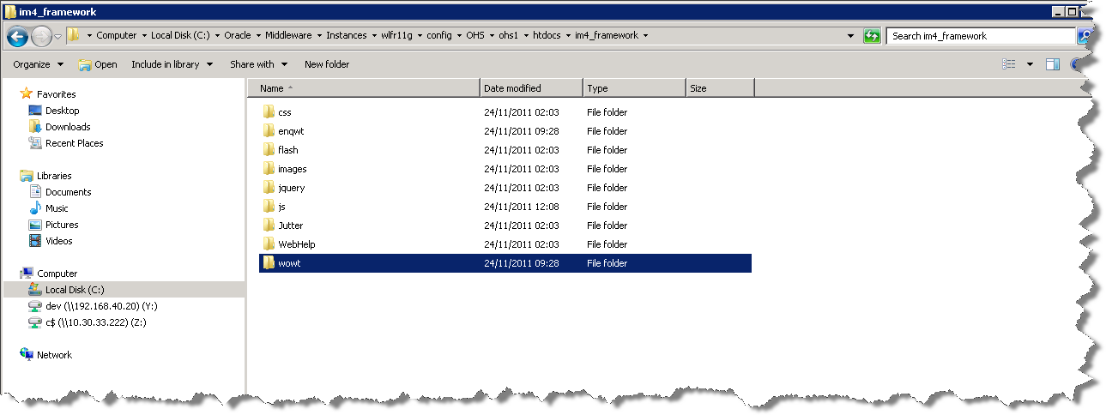

# Enquiry Manager Work Tray

## Implementation of the Enquiry Manager Work Tray Software files

To install the software components for Enquiry Manager Work Tray first check that the ENQWT folder is present and correctly unzipped from the release zip file.

Important:

All exor applications that you install must go into the same destination – what is often referred to as <exor_base>.

## Enquiry Manager Work Tray Server Install

This chapter provides details of steps involved in installing the server components for Enquiry Manager Work Tray.

Important:

This product will require installing after Network Manager, Maintenance Manager, Enquiry Manager and Information Manager.

### **Before you Start**

Before proceeding please ensure that the pre-requisites mentioned in **Section 2.3** of this document are met.

Also, please be aware of the following;

Where instructed to change to a directory before running a script, it is assumed that you are running SQL*PLUS from a DOS Command prompt.

If you are running SQL*PLUS in windows you should set the 'start in' directory of the SQL*PLUS shortcut to simulate the change of directory.

**If you do not run SQL*PLUS from the directory stated in each step of the guide, the installation will fail.**

Also, whilst following the instructions in this section you will be required to know the location of <exor_base>. You may recall that whilst undertaking the tasks in the previous subsection you will have implemented software into the location referred to as <exor_base>, for example, C:\EXOR.

### **Typical problems that you may encounter**

It is possible that, when you are running some of the install scripts, errors may be reported saying that objects already exist in the database or that columns already exist on tables. These errors can generally be ignored. If you are in any doubt, please contact the Exor support desk for guidance.

Also during install Warning messages may appear saying that compilation errors have occurred. These warnings can be ignored, since invalid objects will be recompiled prompt later on in the install. However it will be of concern if compilation errors still occur following the re-compilation.

### **Install of Enquiry Manager Work Tray**

To create the base data and objects for Enquiry Manager Work Tray modules;

Change directory to <exor_base>\enqwt\install

Login to SQL*PLUS as the highways owner on the client PC and run the following command:

  start enqwt_inst.sql

You will be prompted to enter the path of the location of your highways software. This should be name of the directory, including disk identifier and a trailing slash character, referred to as <exor_base>.

For example, if you installed your highways software in a directory called EXOR on your C drive, you would enter the following when prompted.

C:\EXOR\

When you have supplied this value, you will be prompted to confirm that it is correct and asked whether you wish to continue.

If the value specified is not correct or does not end with a slash character, you will be given an error message and the installation script will abort. You will then need to login to SQL*PLUS again and rerun the script.

When the script has completed, all the Enquiry Manager Work Tray objects and data will have been installed.

**Checking Log File(s)**

The following log files are produced in the working directory. At the end of the installation, the files can be viewed to check for any errors that could have occurred during installation.

enqwt_install_1_<**date&time**>.LOG

enqwt_install_2_<**date&time**>.LOG

Please raise and attach the logs to a ticket with <http://selectservices.bentley.com> to allow Bentley (formerly exor) support staff to verify the install has been successful.

### **Upgrade of Enquiry Manager Work Tray**

This section describes the steps necessary to upgrade Enquiry Manager Work Tray to 4.7.0.0

To upgrade the base data and objects for the Enquiry Manager Work Tray modules;

Change directory to <exor_base>\enqwt\install

Login to SQL*PLUS as the highways owner on the client PC

Run one of the following commands depending on which version you are upgrading from.

For an upgrade from 4.6

start enqwt4600_ enqwt4700.sql

For an upgrade from 4.5:

start enqwt4500_ enqwt4700.sql

You will be prompted to enter the path of the location of your highways software. This should be name of the directory, including disk identifier and a trailing slash character, referred to as <exor_base>.

For example, if you installed your highways software in a directory called EXOR on your C drive, you would enter the following when prompted.

C:\EXOR\

When you have supplied this value, you will be prompted to confirm that it is correct and asked whether you wish to continue.

If the value specified is not correct or does not end with a slash character, you will be given an error message and the installation script will abort. You will then need to login to SQL*PLUS again and rerun the script.

When the script has completed, all the Enquiry Manager Work Tray objects and data will have been upgraded.

**Checking Log File(s)**

The following log files are produced in the working directory. At the end of the upgrade, they can be viewed to check for any errors that could have occurred during the upgrade process.

enqwt<**xx**>00_enqwt4700_1_<**date&time**>.LOG

enqwt<**xx**>00_enqwt4700_2_<**date&time**>.LOG

where <xx> refers to the original release number (i.e. 45 or 46)

Please raise and attach the logs to a ticket with <http://selectservices.bentley.com> to allow Bentley (formerly exor) support staff to verify the upgrade has been successful.

Due to interdependencies between some Exor products, please ignore all compilation errors until all of your products have been upgraded.

### **Mandatory Configuration**

**exor_version.txt**

Before accessing Enquiry Manager Work Tray you must check the file exor_version.txt.

This file is referenced in Windows Registry setting ‘EXOR_VERSION’ and by default can be located in the <exor_base>\bin directory.

Ensure that the entry for Enquiry Manager Work Tray is set accordingly;

**ENQWT=4.7.0.1**

### **Product Licensing (Post Install only)**

Following first time installation you must license the product for use.

To do this start highways by exor and invoke module **HIG1890** from the **Fastpath** menu.



For further details please refer to the “**Network Manager General System Admin Guide**”.

### **Additional Configuration (Post Install and Upgrade)**

Consult the documentation that accompanies this release for details of any additional configuration that may be required following an install.

For example, to obtain details of product options, and for details of new product features/amendments.

Important:

It is highly recommended that you do this before attempting to use the application.

### **Spatial Configuration (Post Install and Upgrade)**

Specific information regarding the registration of spatial layers can be found in the “**Locator and Web Mapping**” document.

### **HTTP Server Setup (Post Install and Upgrade)**

You will need to copy the <EXOR_BASE>\enqwt\admin\im4_framework directory to the WebLogic Application Server under the **<ORACLE_INSTANCE>**\config\OHS\ohs1\htdocs directory appending to what already exists.

